Capstone project 2

**3) Question 3- (DevOps):   Instructions:**

1. Please include screenshots for each task point mentioned. For each task, take a maximum of 2 or 3 screenshots as required in the problem statement. Not adhering to this will lead to confusion during PRT evaluation, which can affect your marks.Not attaching screenshots for every single step will result in marks being deducted for that particular step, even if the final end goal was correct.
2. For every single resource to be created or set up, installation, or job creation, a point will be assigned. Hence, if you are asked to create 2 resources via Terraform, 1 mark will be assigned for each task. If proper screenshots are not attached for a particular point, marks for that will not be given, even if it can be deduced from the later screenshots. The performing screenshot must be shared.

**Example 1:**If you attach the successful execution screenshot of the Terraform/Ansible/Jenkins script but not the script itself, marks will not be awarded for that particular section/point. So, screenshots of the scripts used must be shared. **Example 2:** If you attach just the final dashboard screenshot for Jenkins when asked to share the Jenkins Dashboard setup, marks will not be awarded. If you have been asked to set up the Jenkins Dashboard, the entire procedure must be recorded. **Missing any points will result in a loss of marks for that specific point. The examples given above are just instances of how to submit, and the same rules will apply to all the various steps given. Not adhering to the steps will result in the deduction of marks for that particular point.  
Scenario:**Your organization is aiming to automate the infrastructure creation and deployment procedure. You are tasked with setting up and configuring the AWS environment to meet specific requirements. **Question:**

1. Create an Instance in AWS manually which will be acting as the Terraform Master machine using which you have to create a VPC and a Subnet in that VPC, you will then have to create 3 more Instances in that Subnet
2. Any configurations needed to be made has to be achieved using Ansible, i.e. Jenkins and Kubernetes installations in the required Machines.
3. One of the 3 machines created using Terraform will be behaving as the Master for Jenkins and the other will be the Kubernetes Master machine which will be required to be added as a Kubernetes Agent in the Jenkins Dashboard. The third machine will be fulfilling the role of your Kubernetes Slave node which does not need to be added as a Jenkins Agent.
4. A Dockerfile also needs to be created to containerize the website that has been mentioned in the GitHub link provided below. The same is to be achieved by forking the repository on your GitHub account.

**GitHub URL:** https://github.com/Sameer-8080/Website-PRT-ORG

1. A Jenkinsfile has to be created that will be included in the forked repository as well which will also contain the manifest files required. More information on the manifest files required is mentioned in the next point. The Jenkinsfile should build a new image upon changes to the repository to ensure that the latest website is displayed at all times.

**Note: FreeStyle Jobs will not be accepted for this PRT, a Pipeline Job has to be created and creation of FreeStyle Jobs instead will heavily impact the marking negatively.**

1. The manifest file required are:
2. A deployment file that will create the required deployment from the image which will be created from the Dockerfile and uploaded to DockerHub. The deployment will have a total of 5 replicas.
3. A service file which will be of type NodePort which will expose the above mentioned deployment on port 30010.
4. The Jenkins pipeline which will be created should be automatically triggered once changes are made to the forked repository.

#!/bin/bash

# Enable TCPKeepAlive in SSH

echo "TCPKeepAlive yes" | sudo tee -a /etc/ssh/sshd_config

# Set ClientAliveInterval and ClientAliveCountMax in SSH configuration

echo "ClientAliveInterval 120" | sudo tee -a /etc/ssh/sshd_config

echo "ClientAliveCountMax 3" | sudo tee -a /etc/ssh/sshd_config

# Restart SSH service after modifying the configuration

sudo systemctl restart ssh.service

# Sleep for 300 seconds

sleep 300

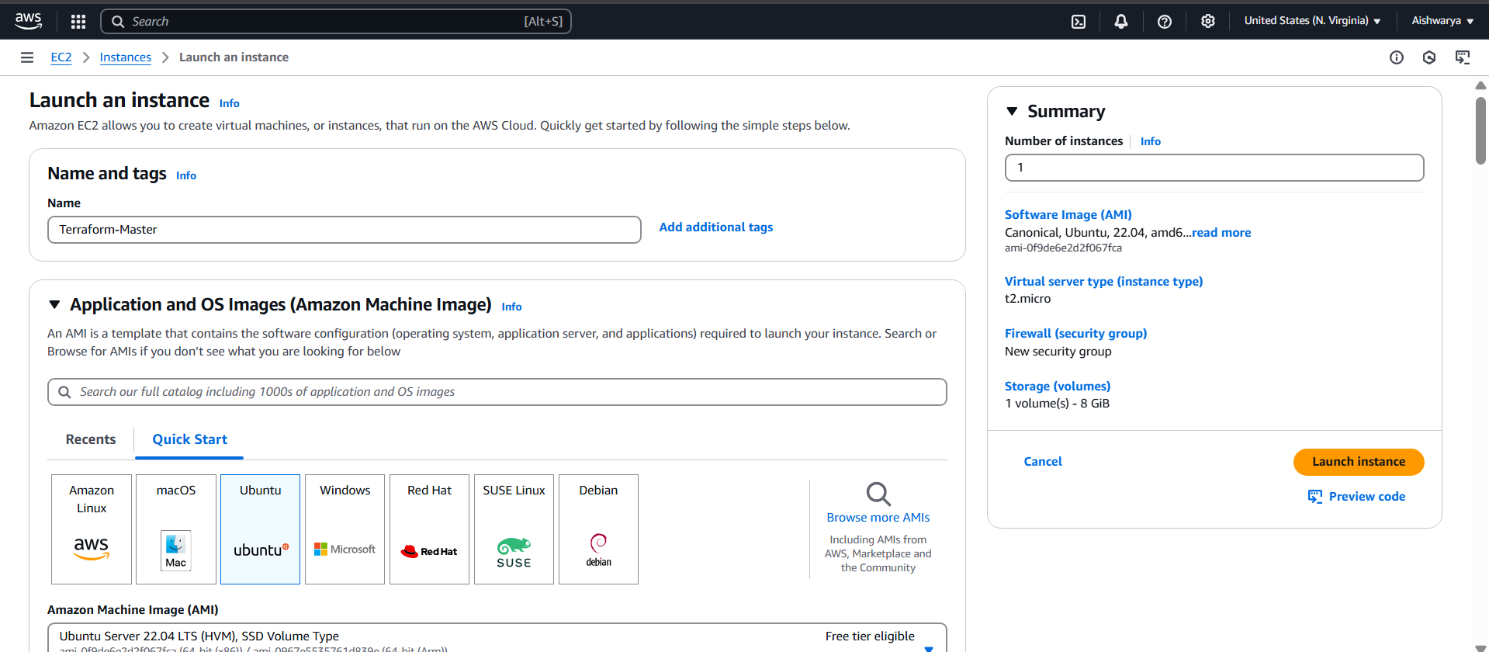

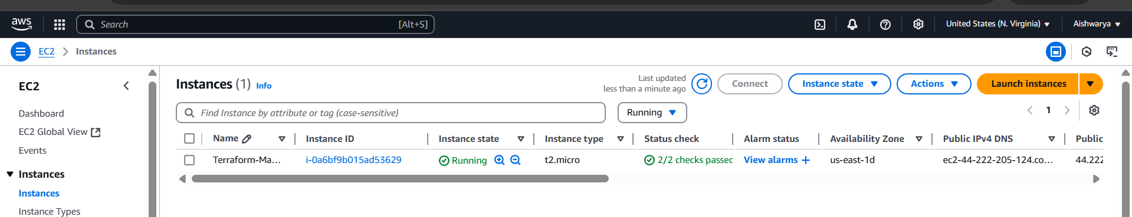

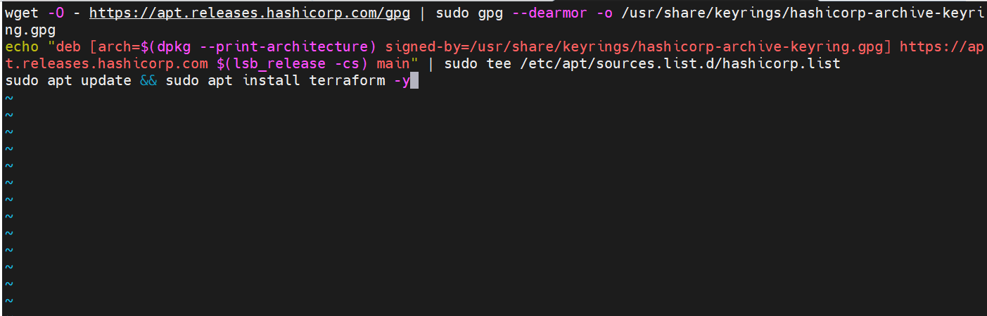

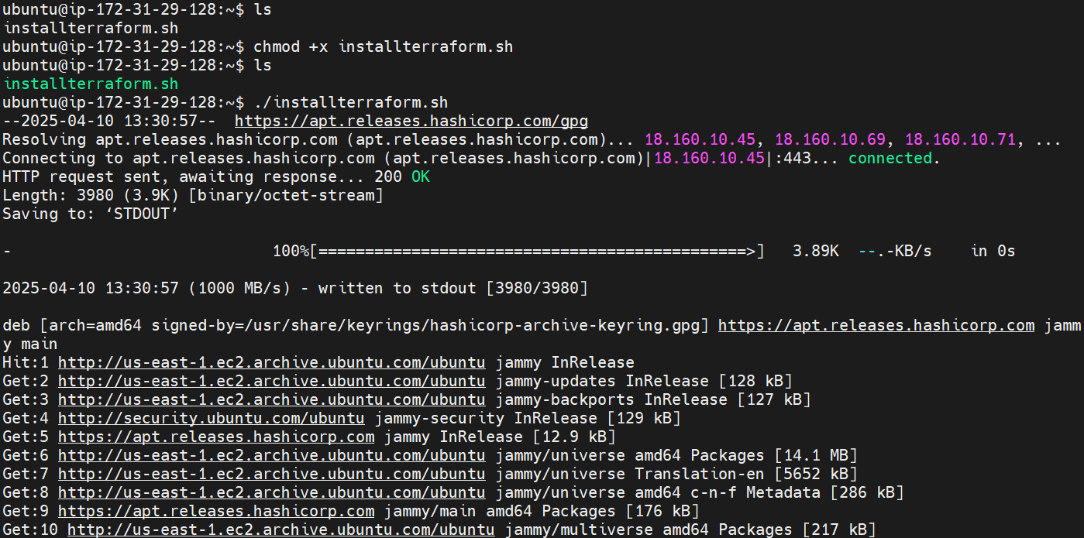

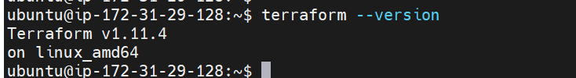



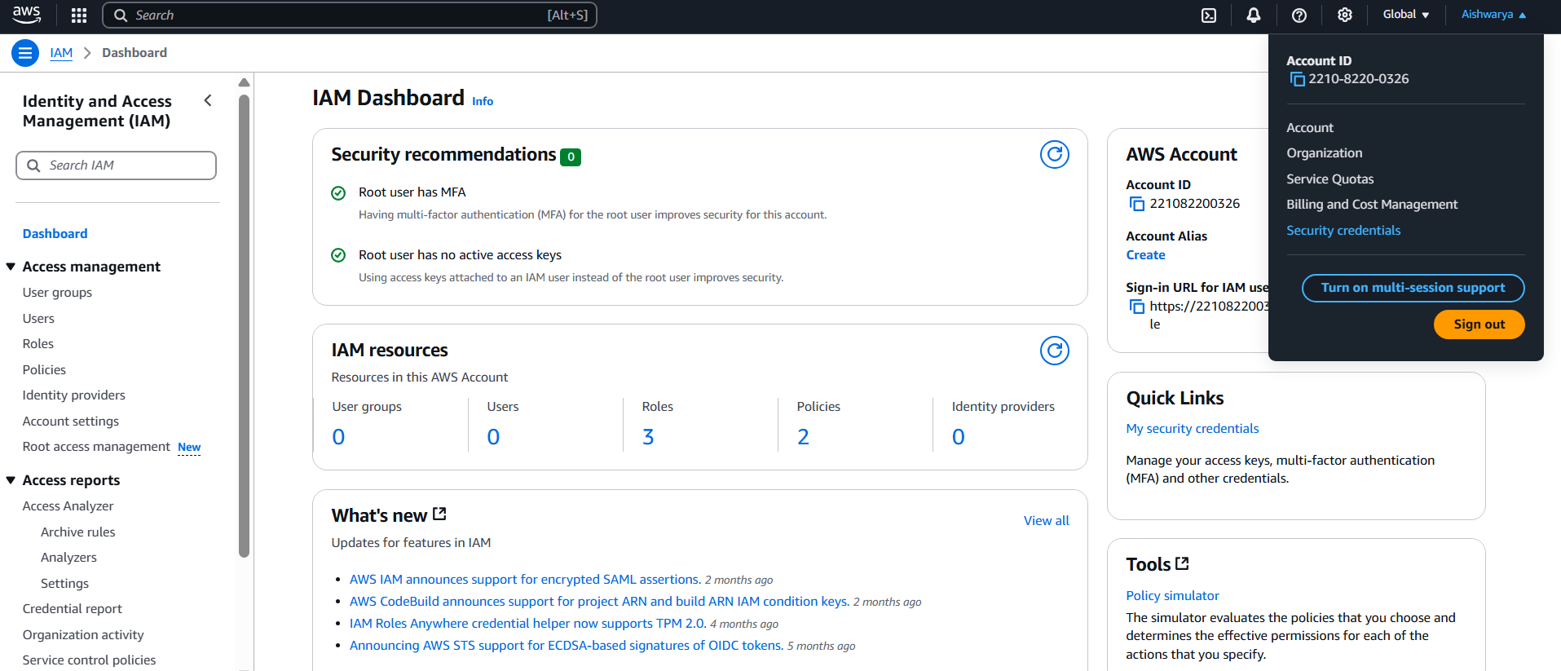

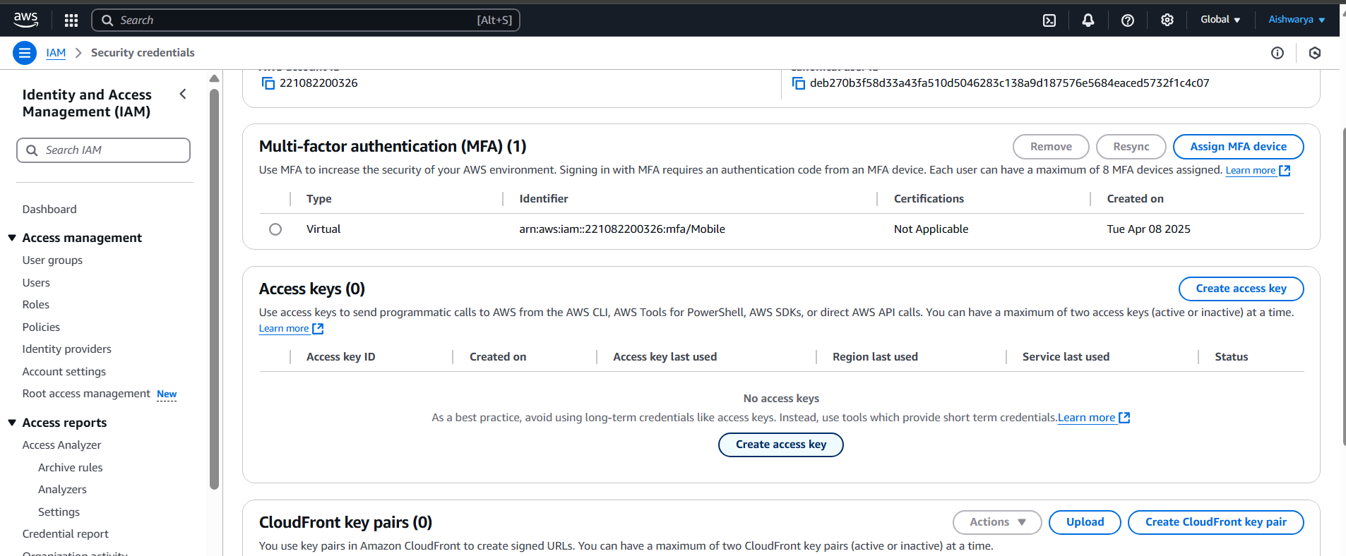

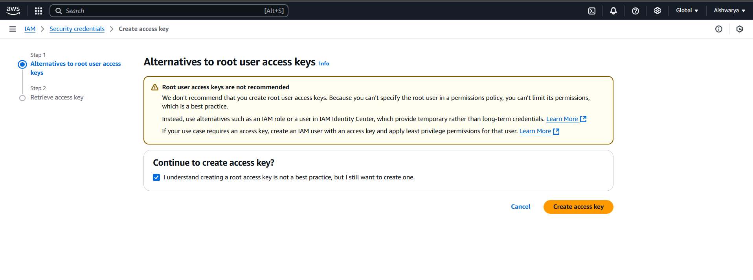

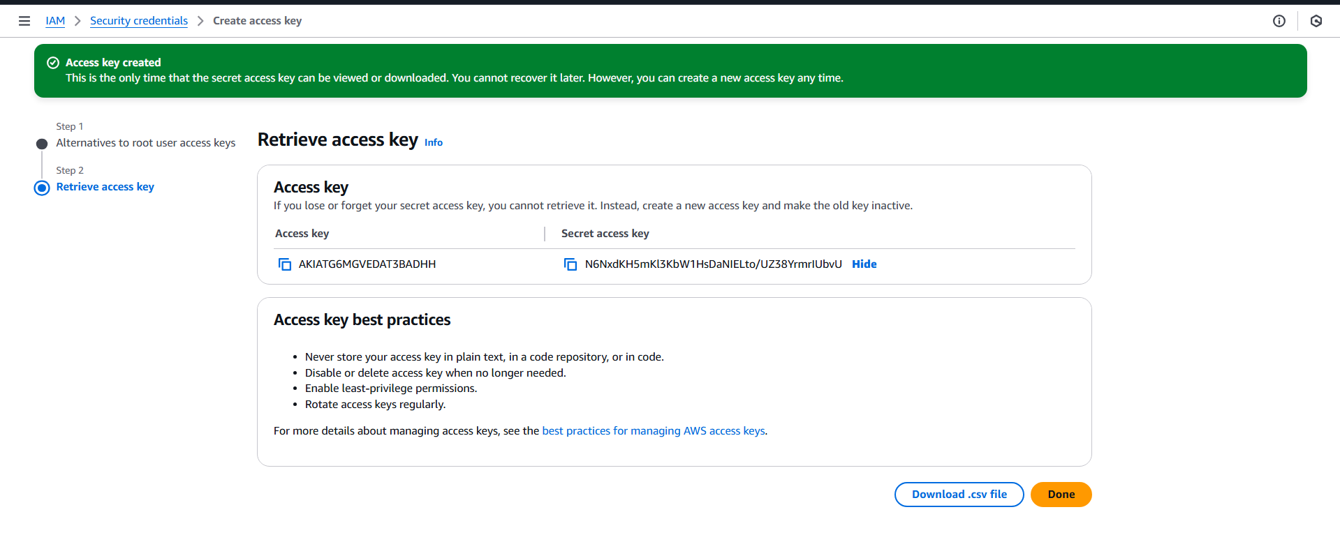

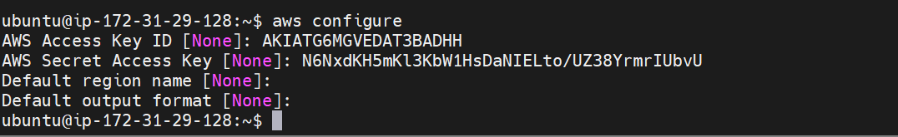

provider "aws" {

region = "us-east-1" # Set your desired AWS region

}

# Create VPC

resource "aws_vpc" "my_vpc" {

cidr_block = "10.0.0.0/16"

enable_dns_support = true

enable_dns_hostnames = true

}

# Create Public Subnet

resource "aws_subnet" "my_public_subnet" {

vpc_id = aws_vpc.my_vpc.id

cidr_block = "10.0.1.0/24"

availability_zone = "us-east-1b"

map_public_ip_on_launch = true # Enable public IP on launch

}

# Create Private Subnet

resource "aws_subnet" "my_private_subnet" {

vpc_id = aws_vpc.my_vpc.id

cidr_block = "10.0.2.0/24"

availability_zone = "us-east-1b"

}

# Create Internet Gateway

resource "aws_internet_gateway" "my_igw" {

vpc_id = aws_vpc.my_vpc.id

}

# Create Route Table

resource "aws_route_table" "my_route_table" {

vpc_id = aws_vpc.my_vpc.id

route {

cidr_block = "0.0.0.0/0"

gateway_id = aws_internet_gateway.my_igw.id

}

}

# Associate Subnet with Route Table

resource "aws_route_table_association" "my_subnet_association" {

subnet_id = aws_subnet.my_public_subnet.id

route_table_id = aws_route_table.my_route_table.id

}

# Create Security Group

resource "aws_security_group" "my_security_group" {

vpc_id = aws_vpc.my_vpc.id

# Ingress rules for SSH and HTTP (port 22 and 80)

ingress {

from_port = 0

to_port = 0

protocol = "-1"

cidr_blocks = ["0.0.0.0/0"]

}

# Egress rules to allow all outbound traffic

egress {

from_port = 0

to_port = 0

protocol = "-1"

cidr_blocks = ["0.0.0.0/0"]

}

}

# Create EC2 Instances

resource "aws_instance" "my_instance" {

count = 3

ami = "ami-0f9de6e2d2f067fca" # Set your desired AMI ID

instance_type = "t2.medium" # Set your desired instance type

subnet_id = aws_subnet.my_public_subnet.id

key_name = "projectkeypair" # Set your key pair name

security_groups = [aws_security_group.my_security_group.id]

associate_public_ip_address = true # Associate a public IP address

tags = {

Name = "Kubernetes-${count.index + 1}"

Environment = "Development"

}

}

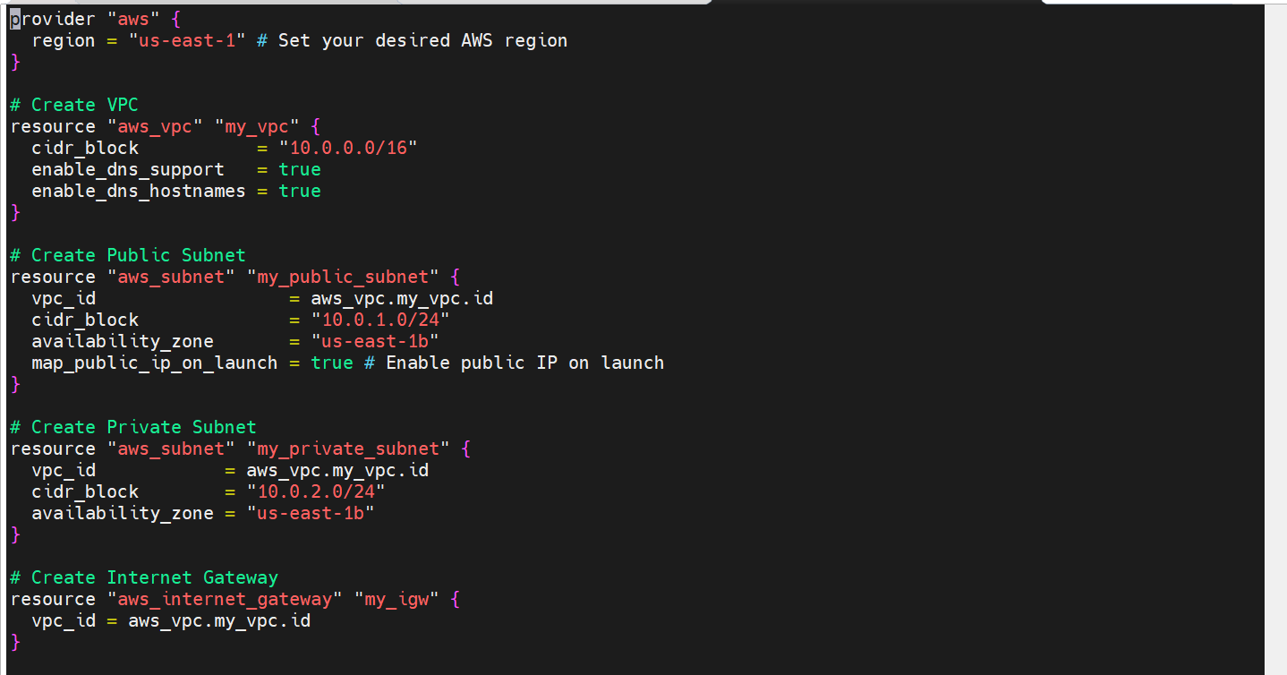

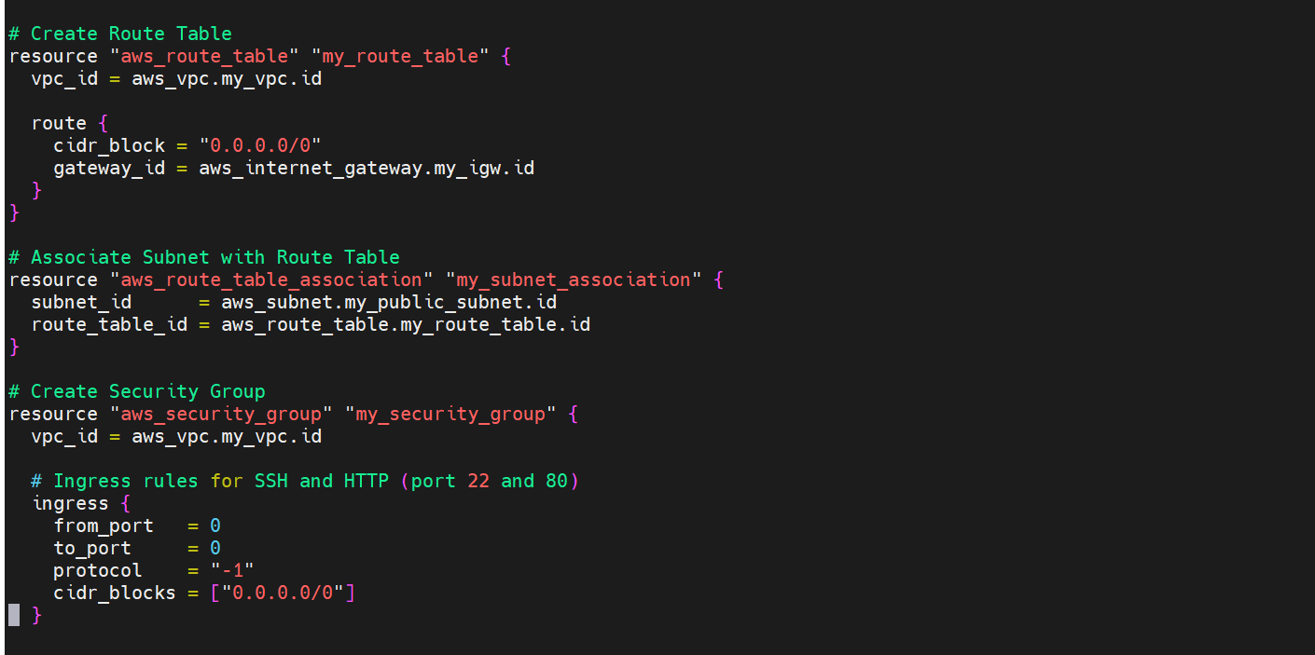

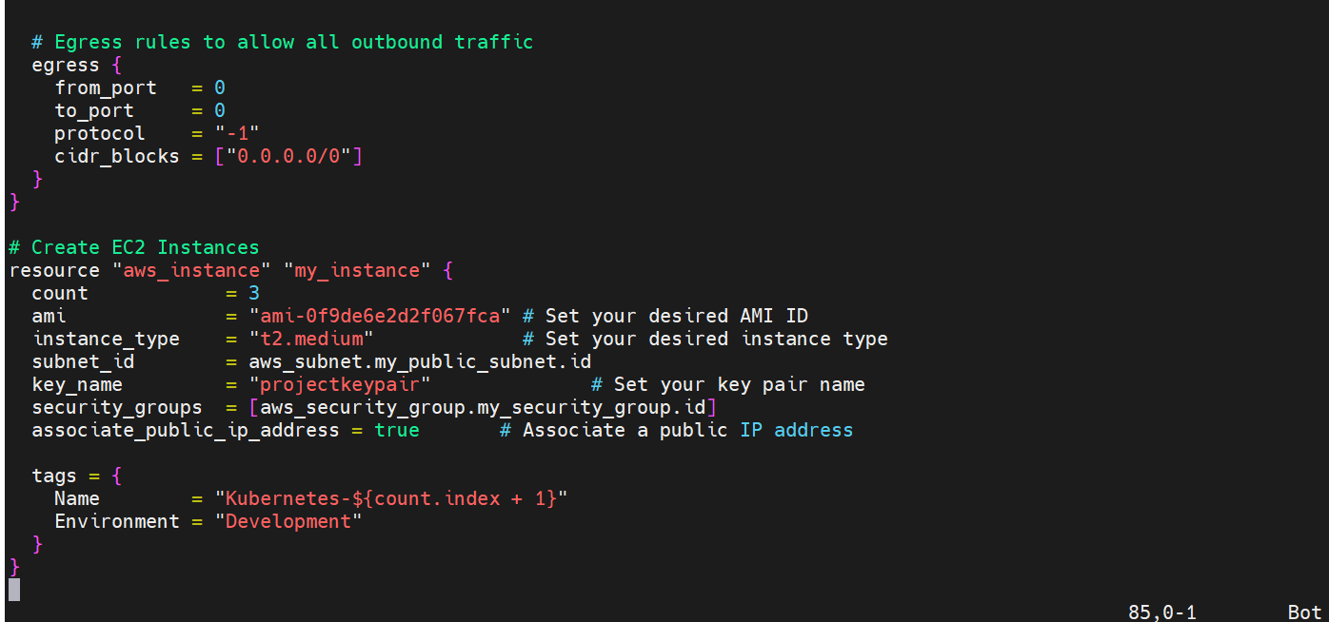

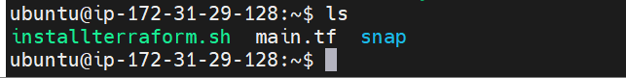

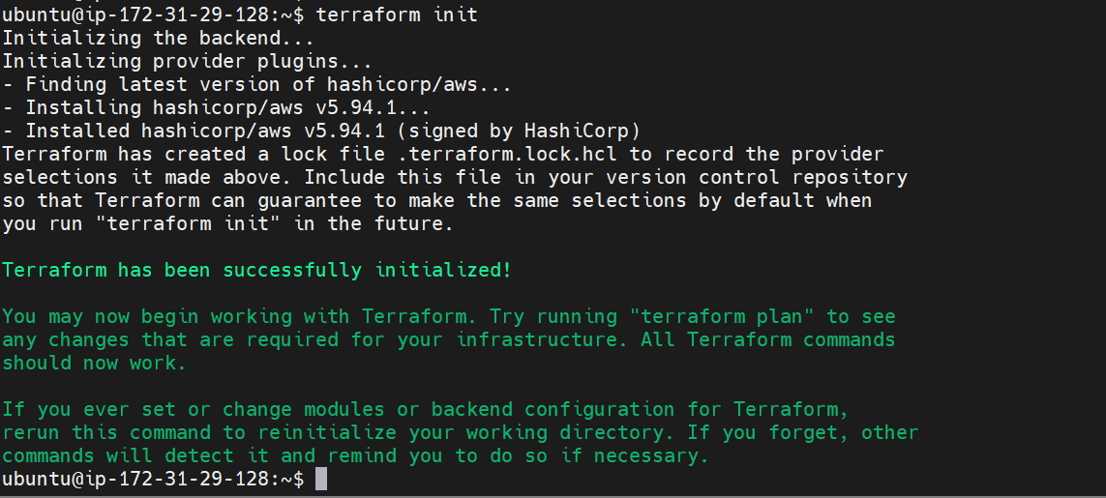

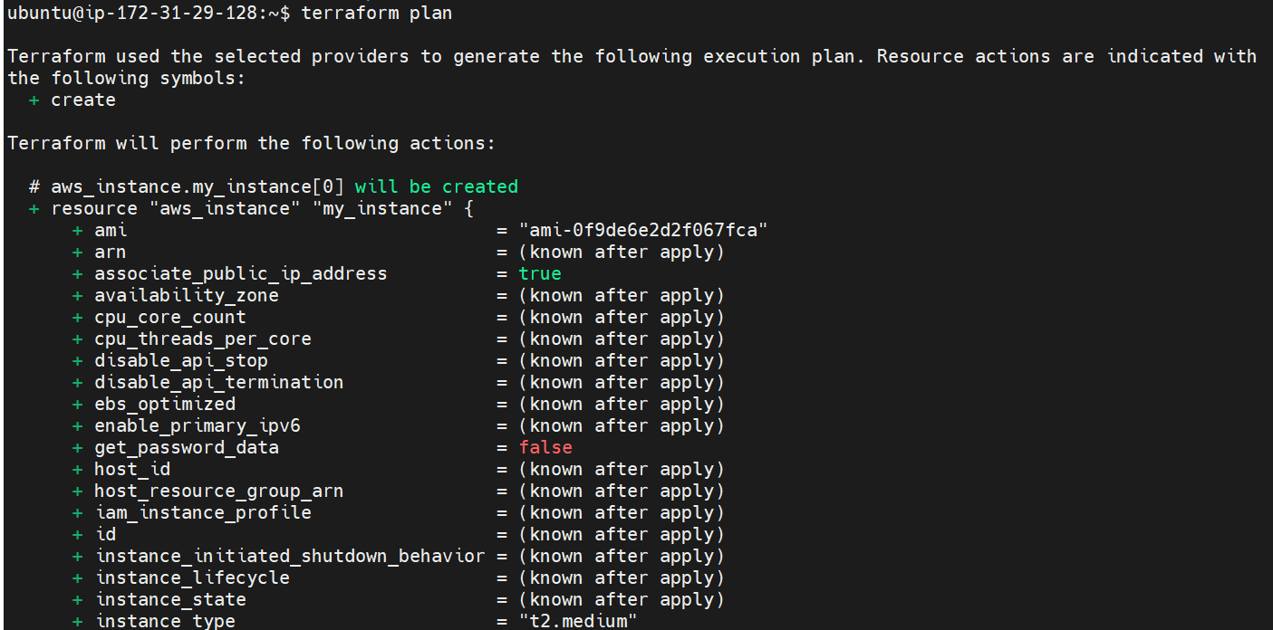

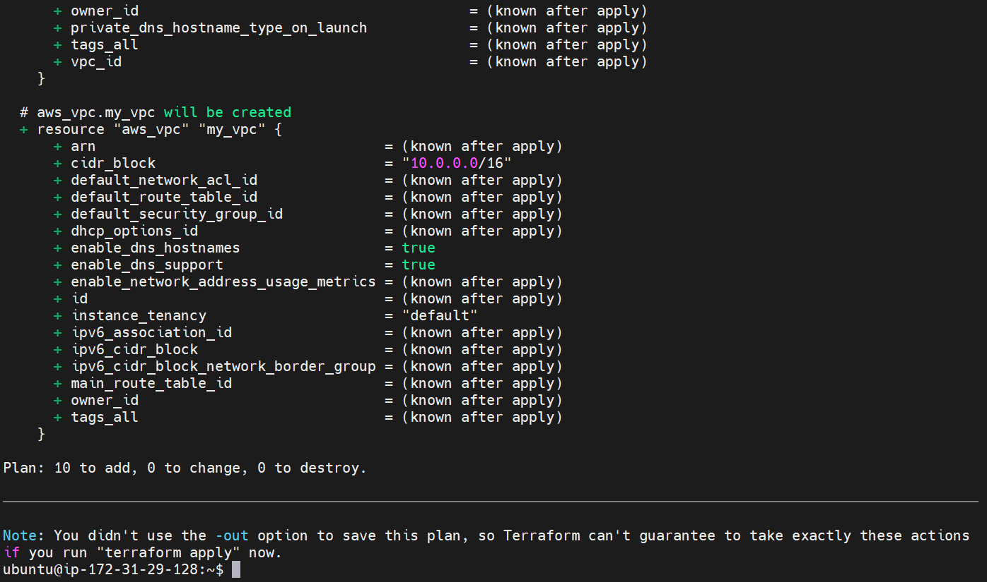

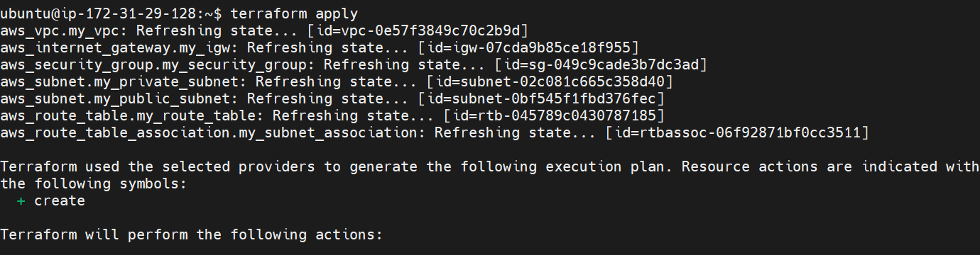

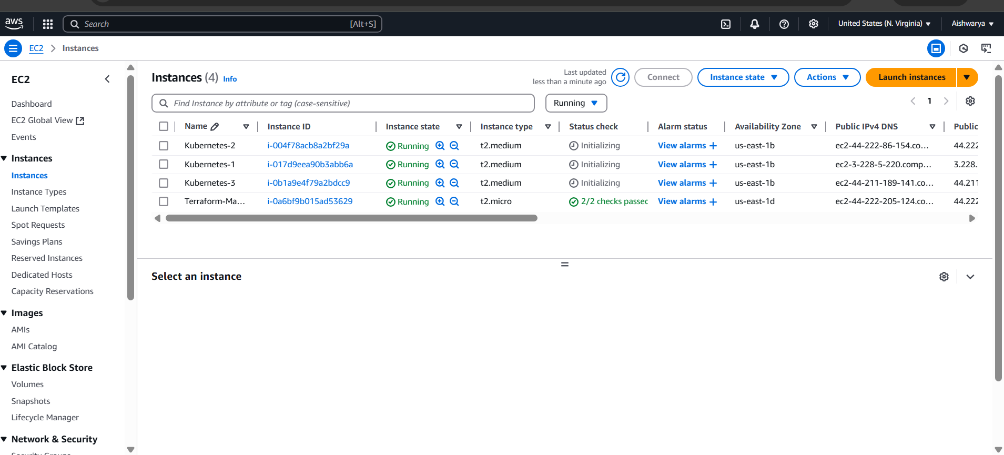

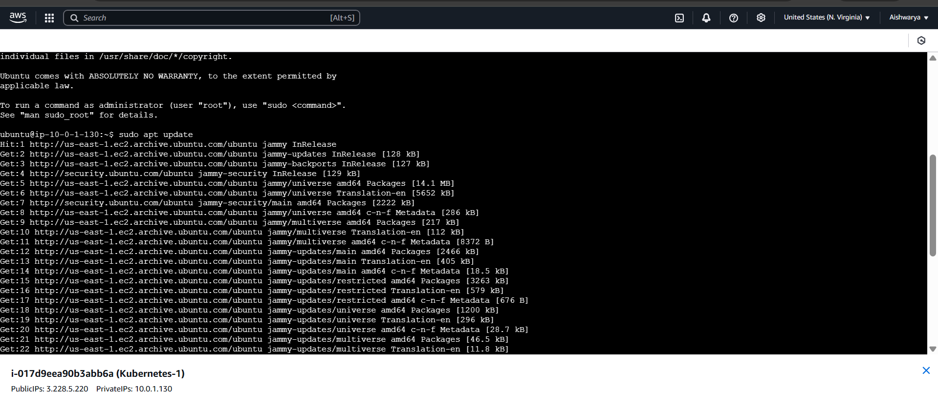

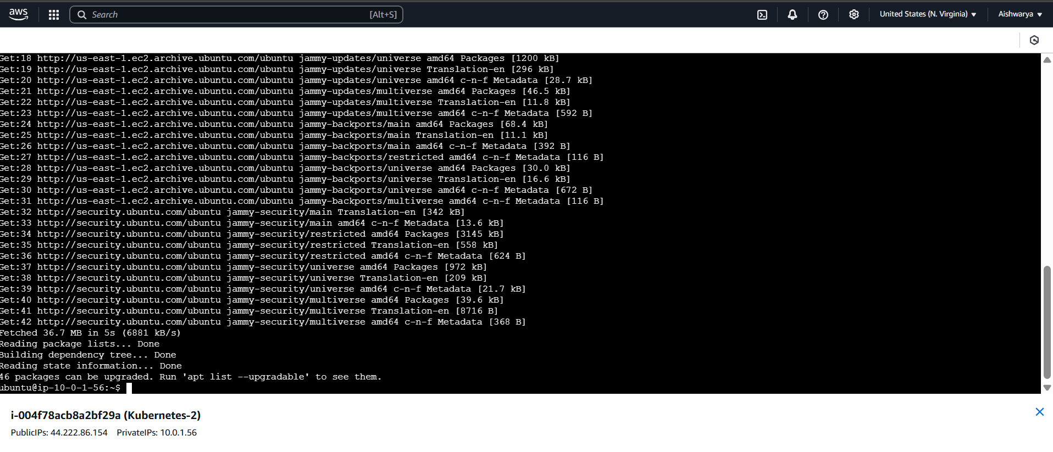

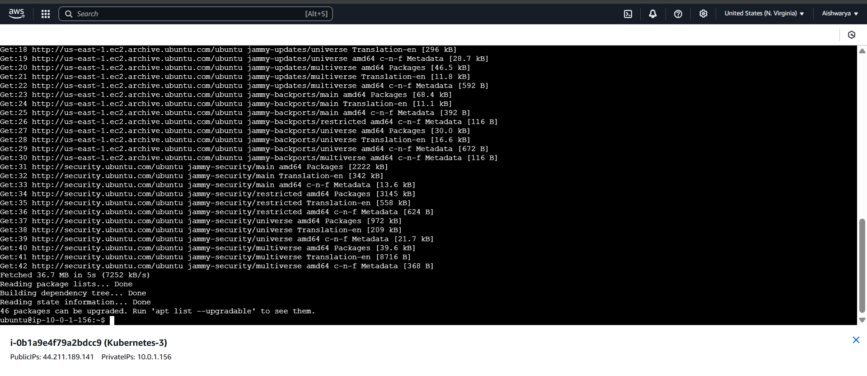

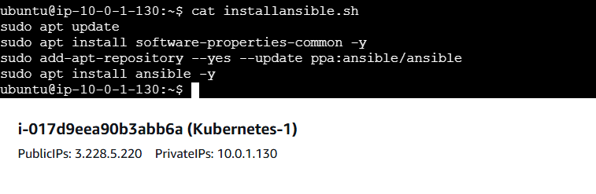

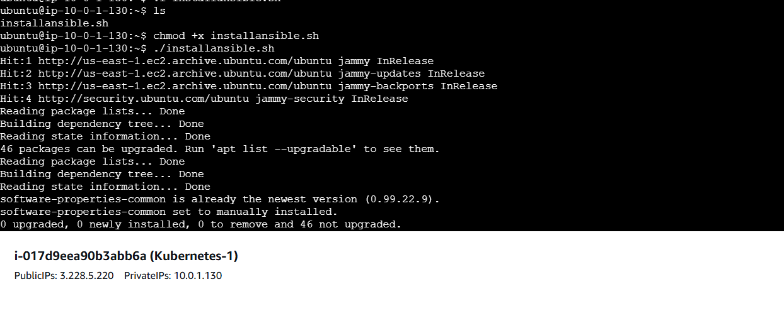

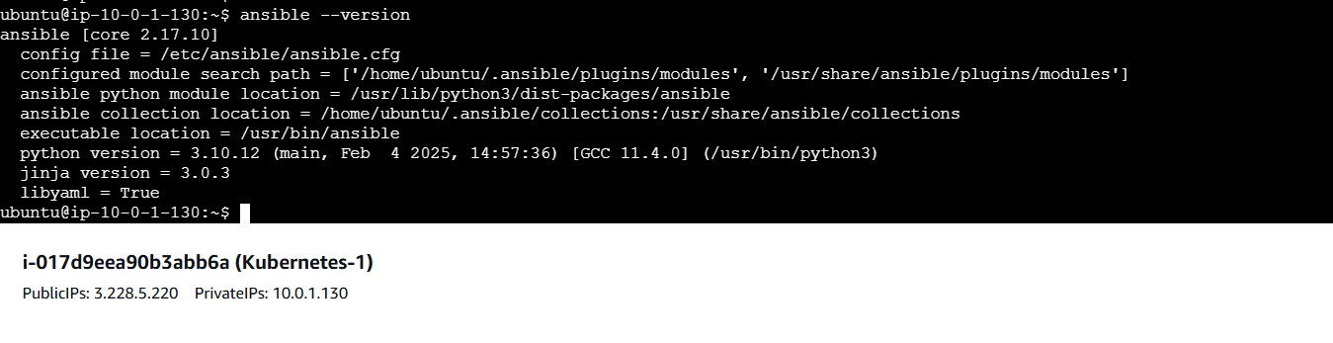

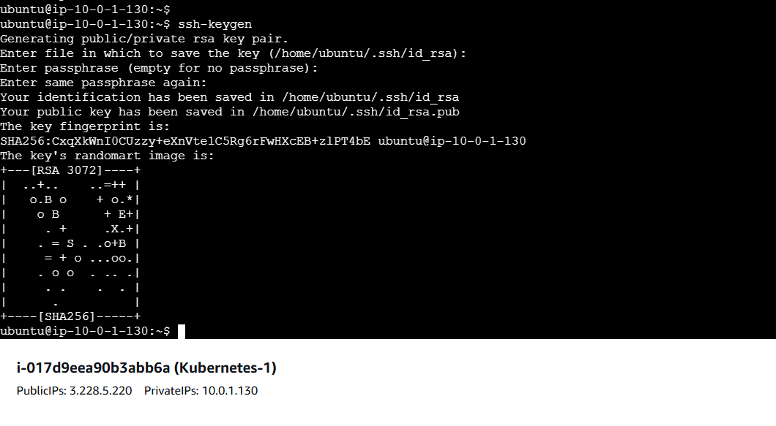

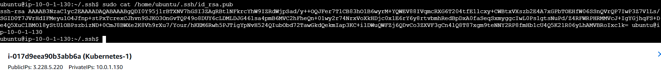

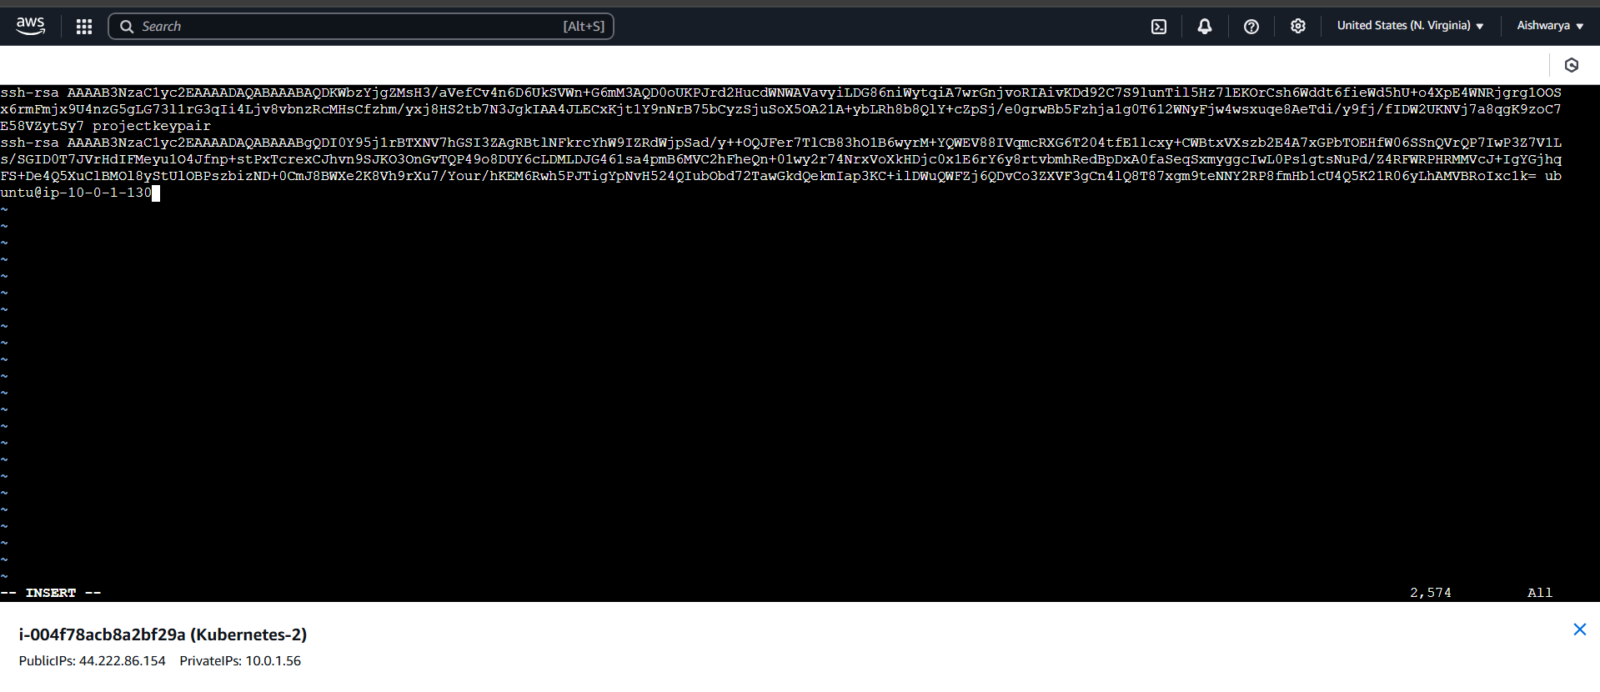

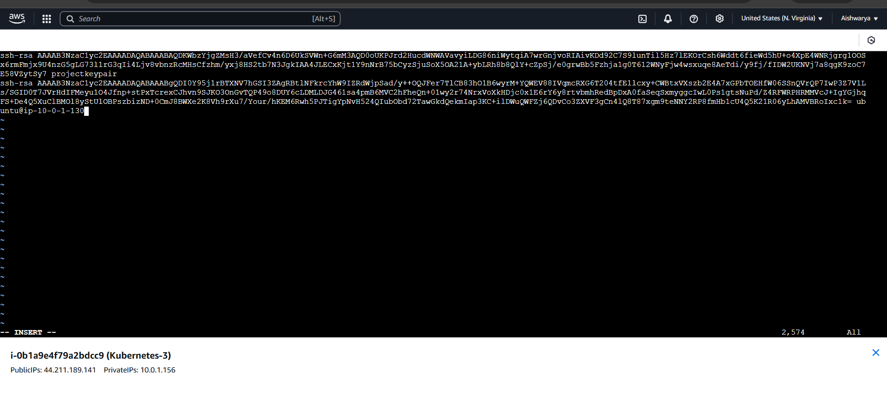

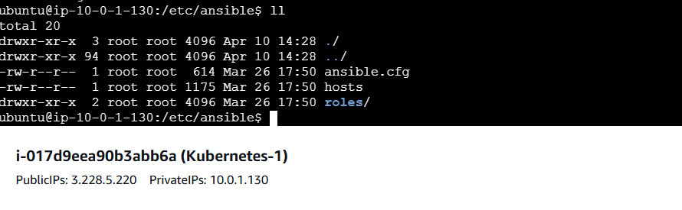

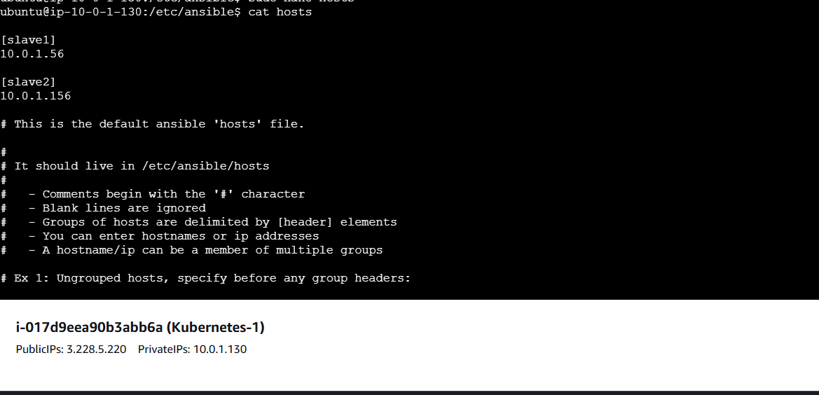

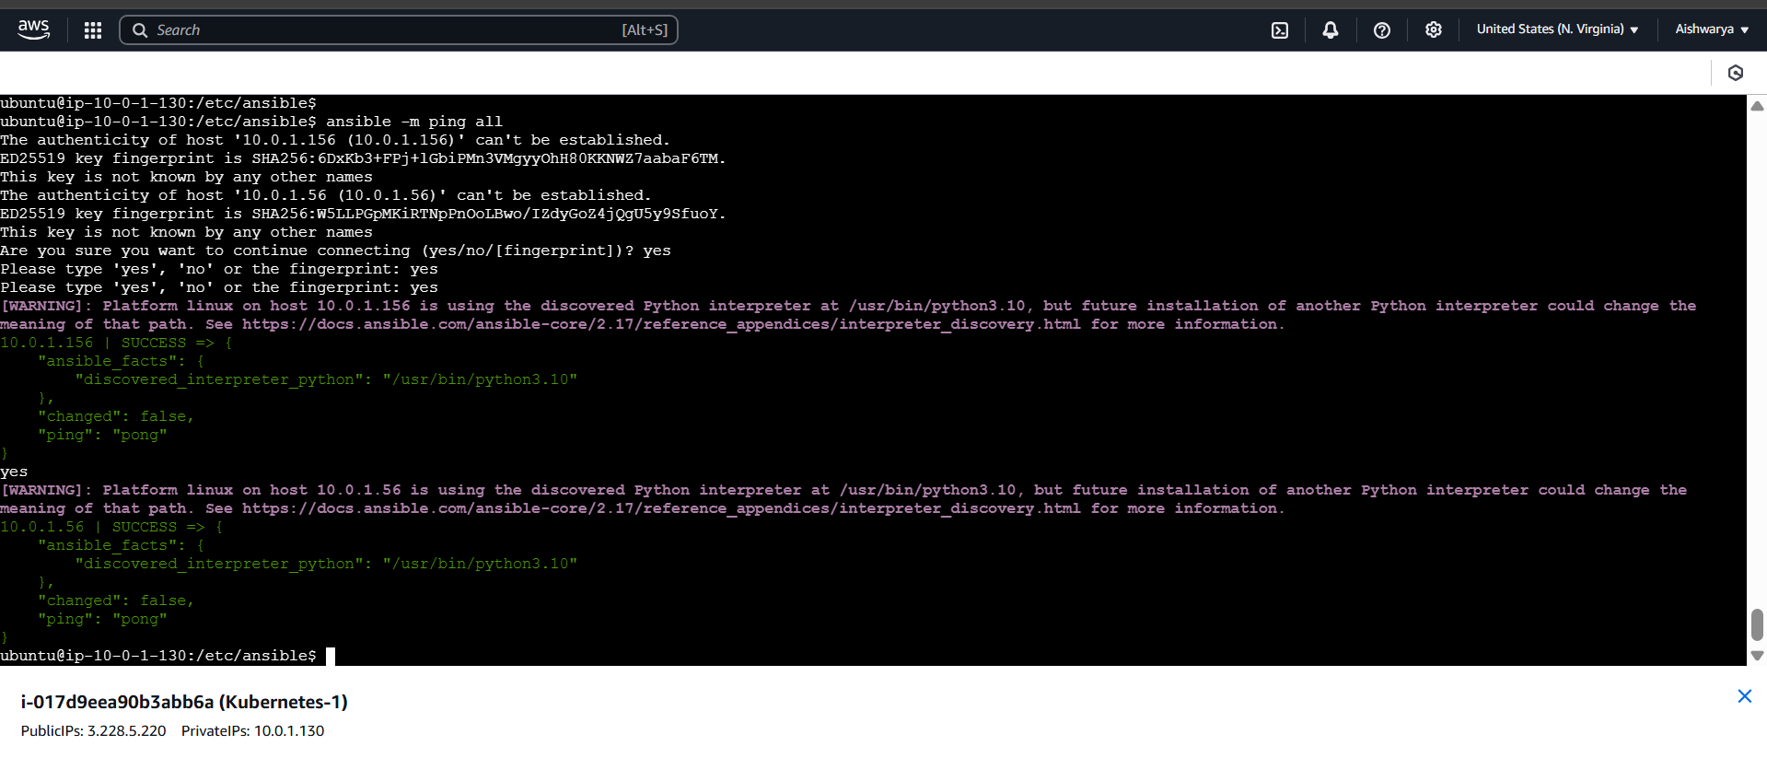

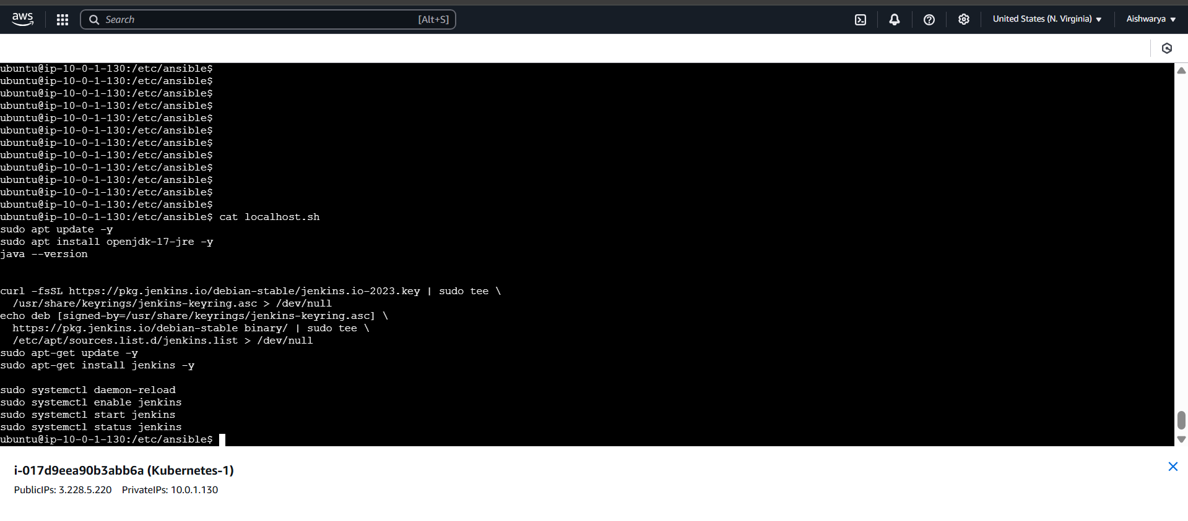

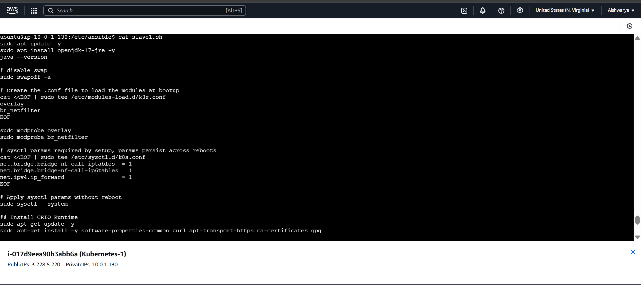

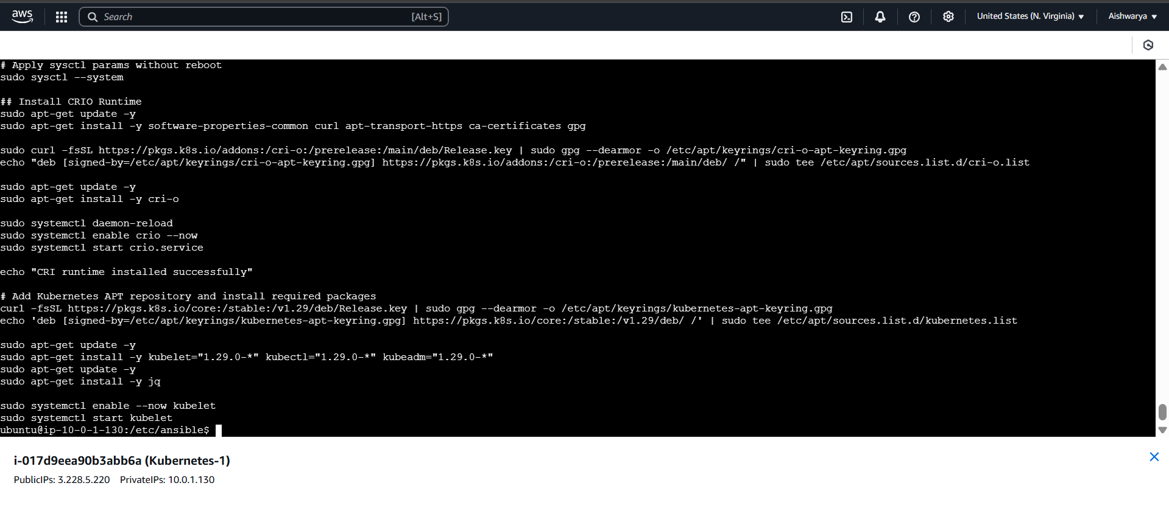

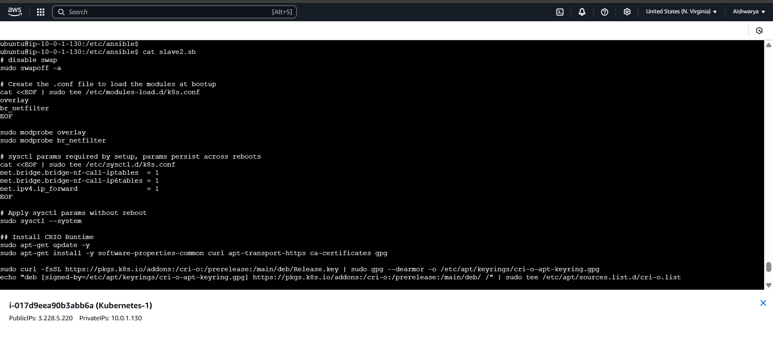

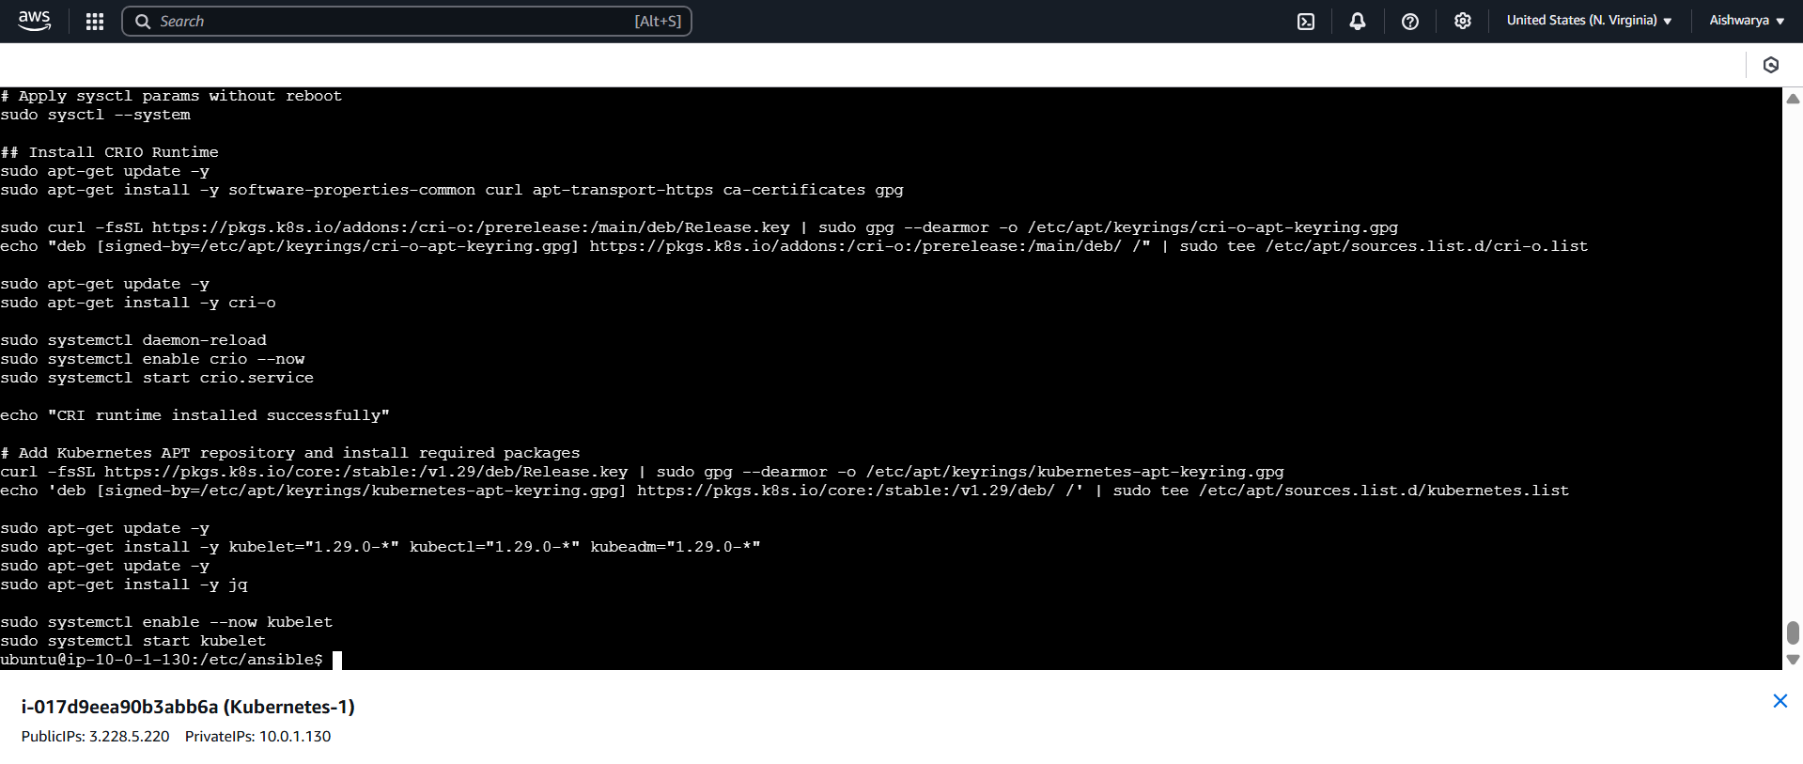

Give execute permission

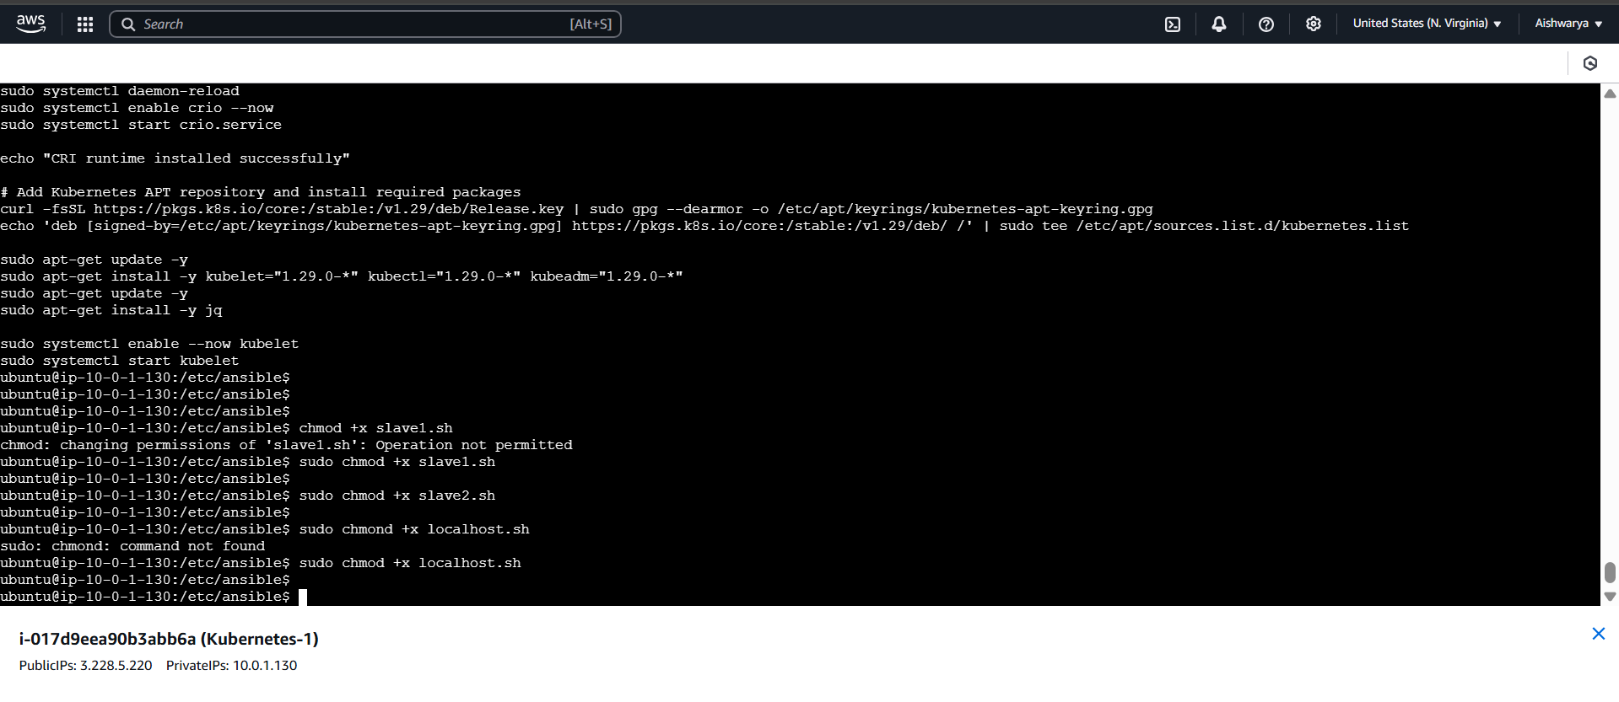

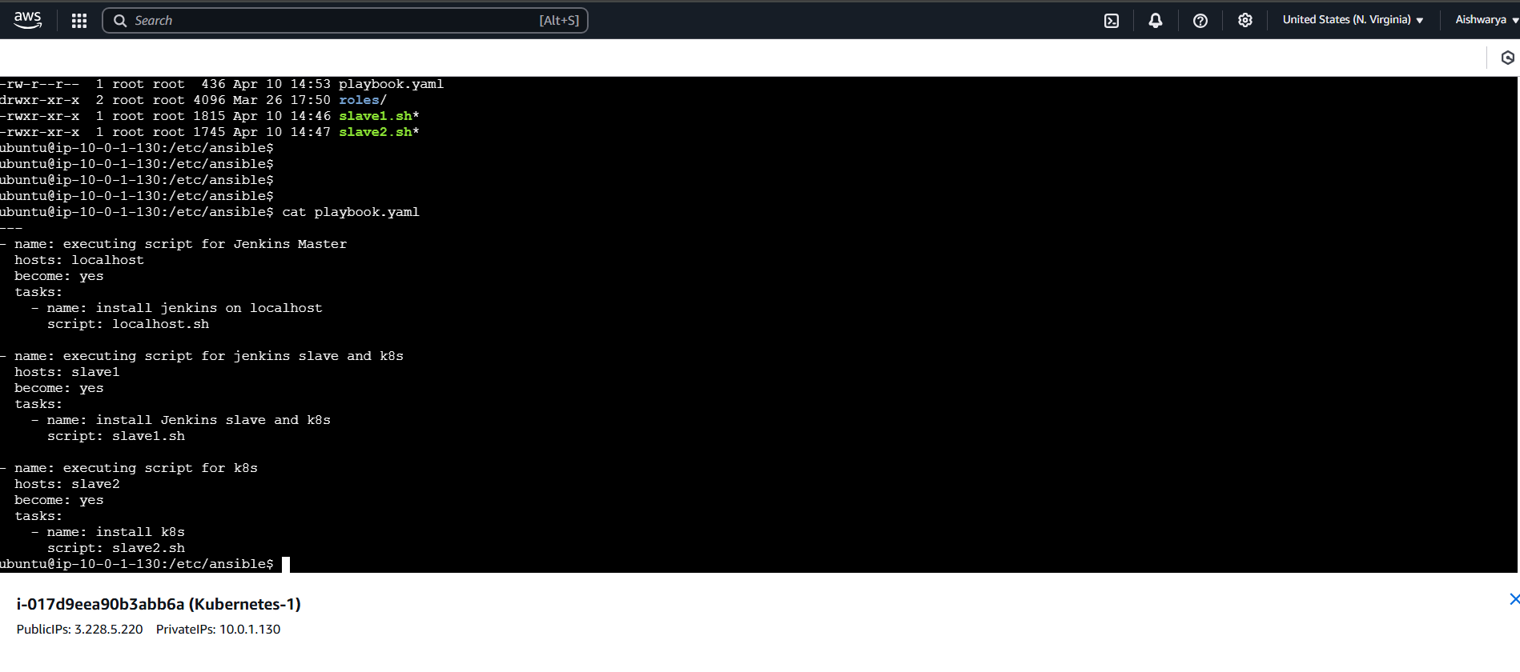

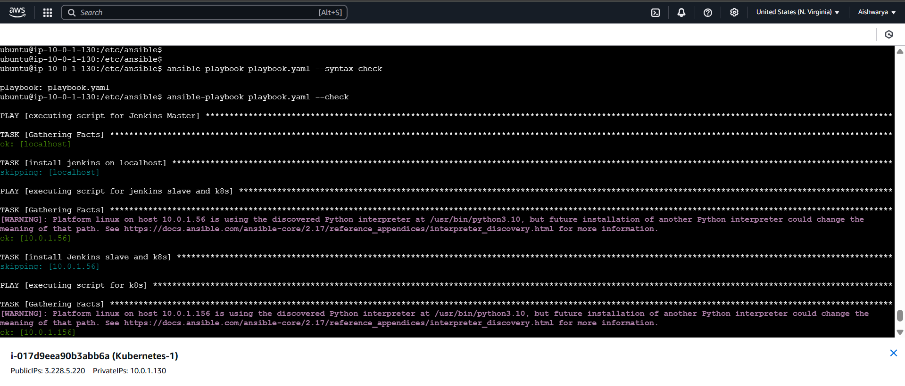

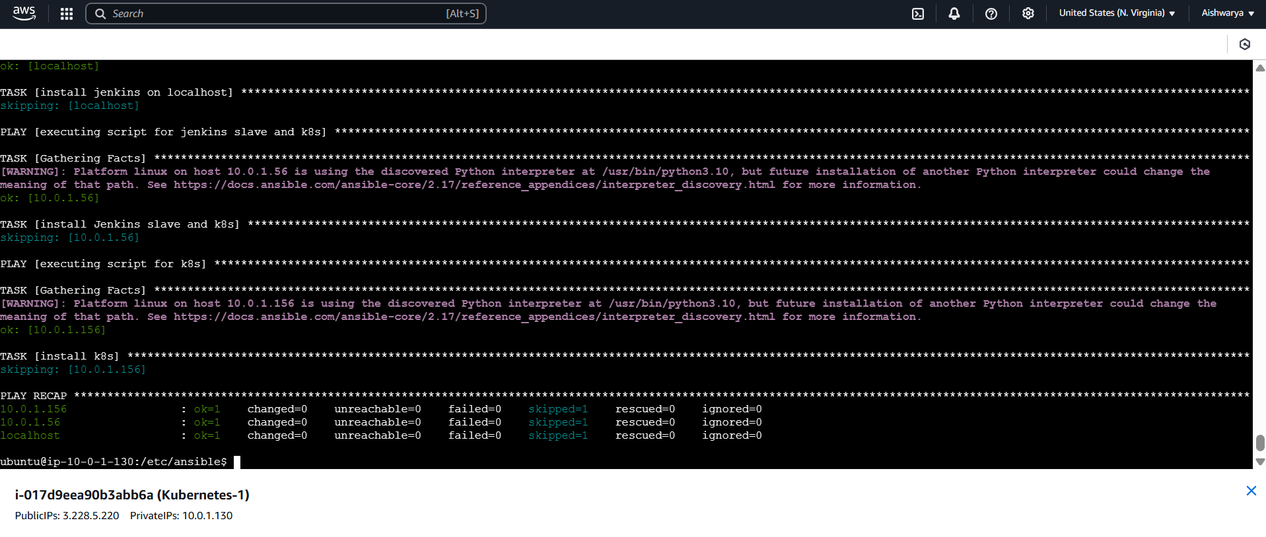

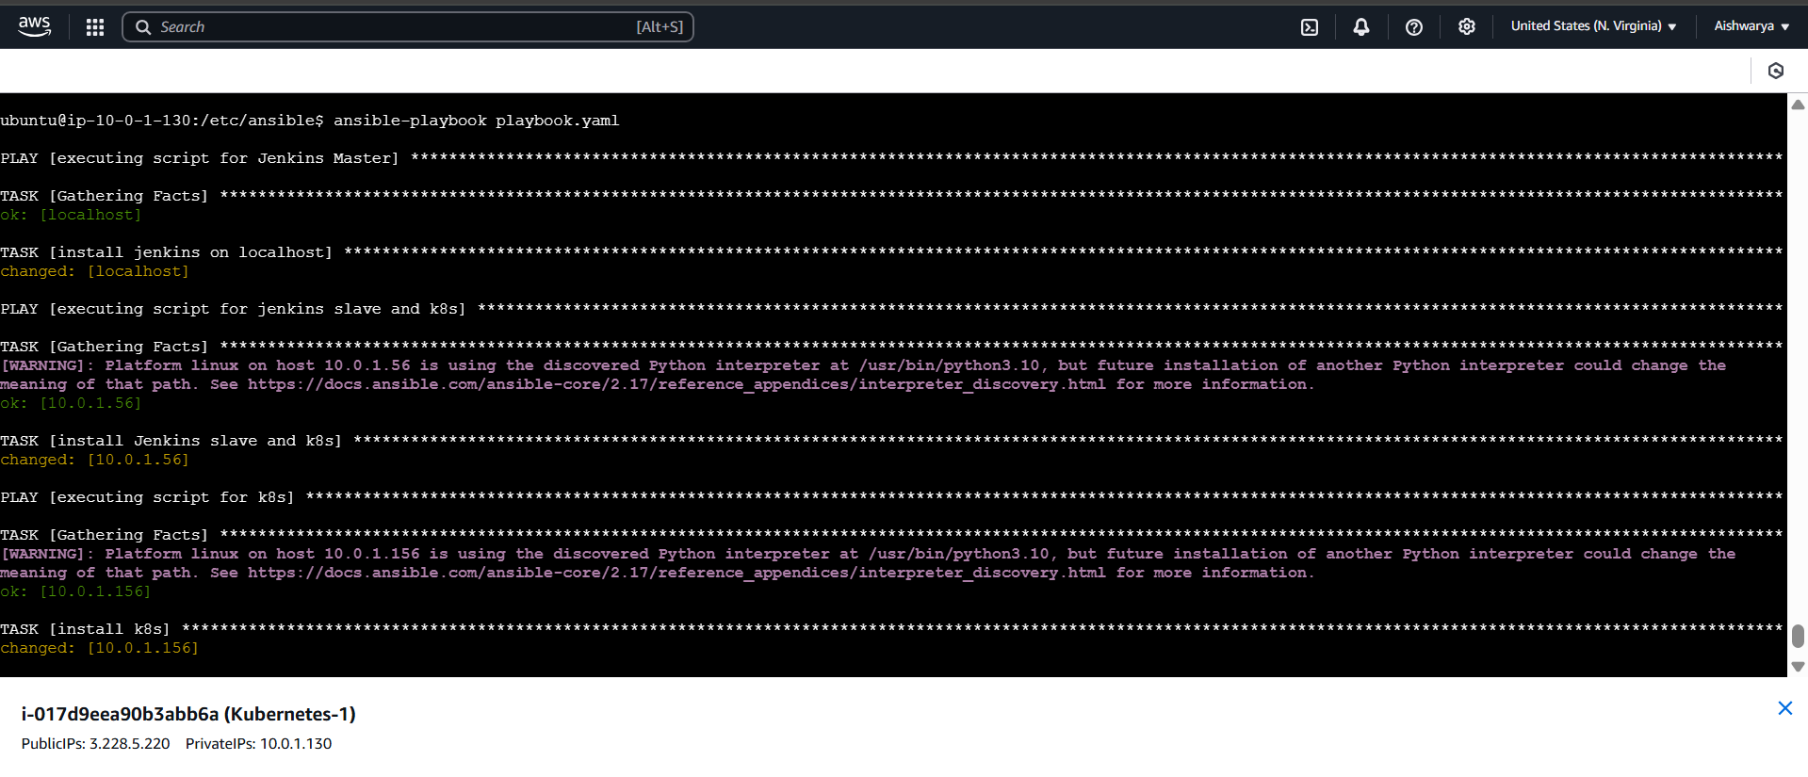

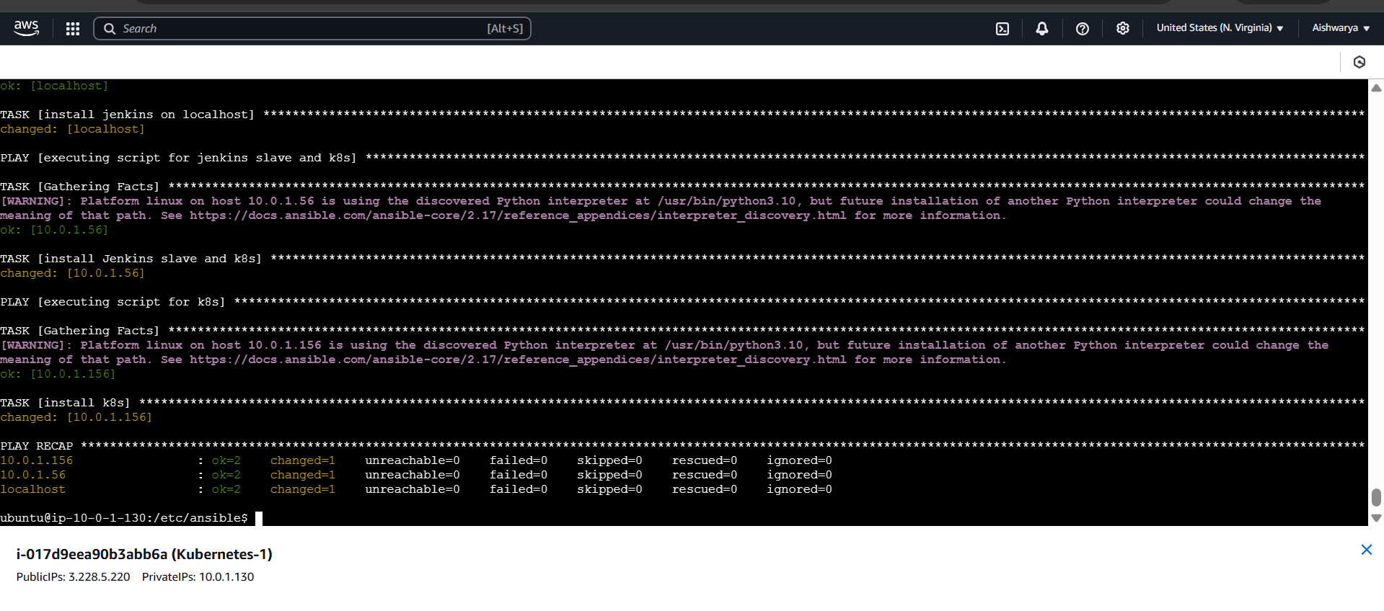

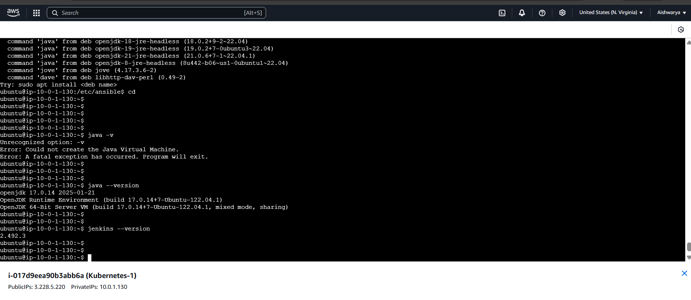

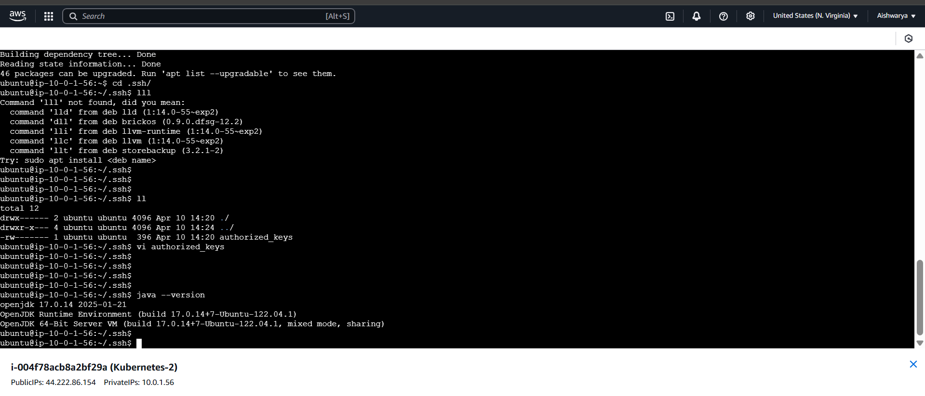

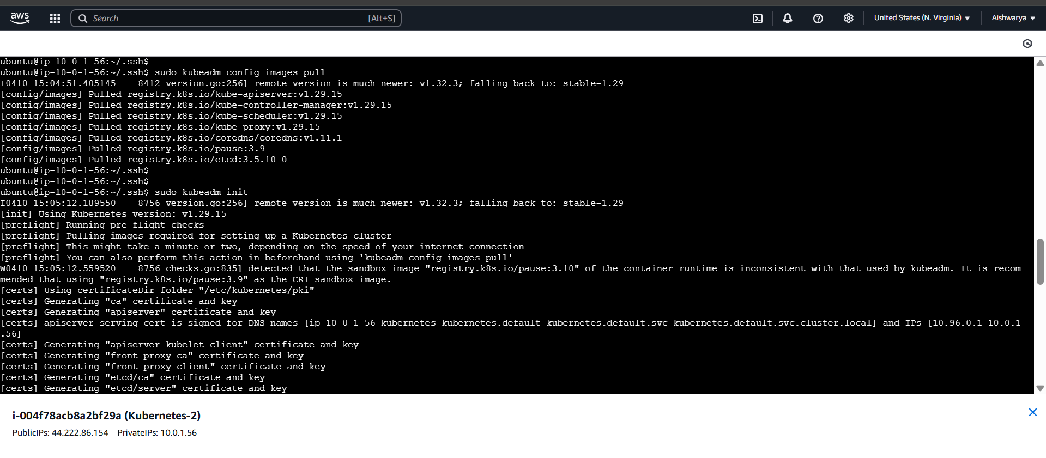

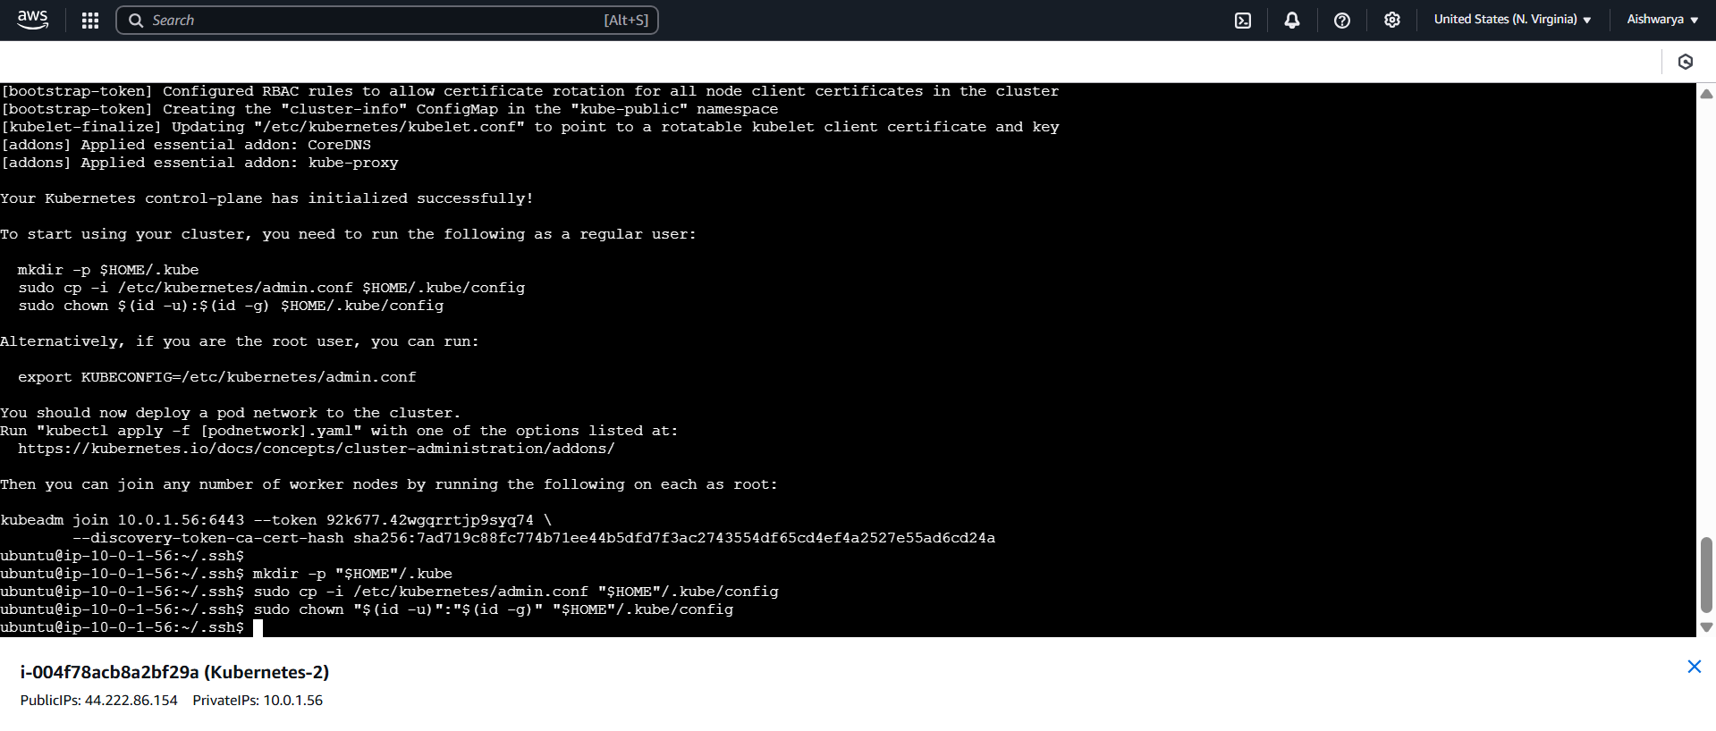

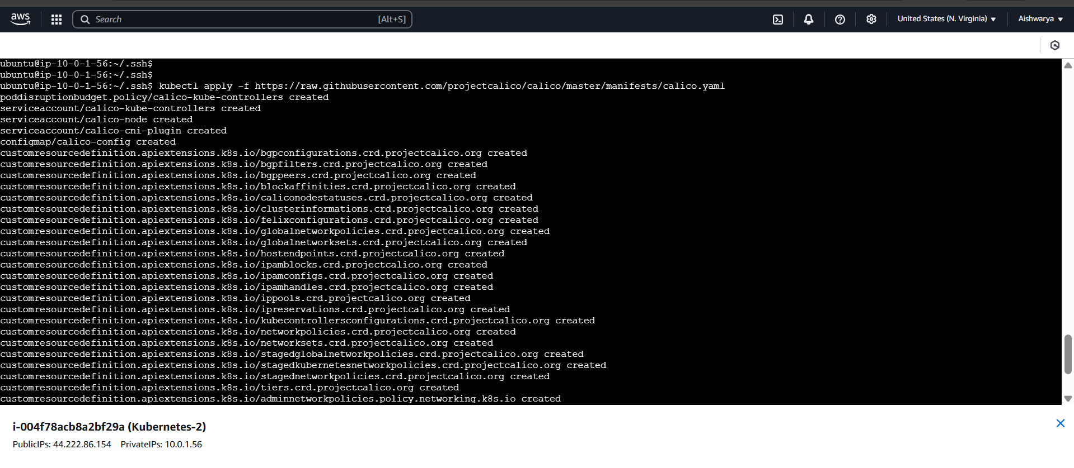

**## Execute ONLY on "Master Node"**

**sudo kubeadm config images pull**

**sudo kubeadm init**

**mkdir -p "$HOME"/.kube**

**sudo cp -i /etc/kubernetes/admin.conf "$HOME"/.kube/config**

**sudo chown "$(id -u)":"$(id -g)" "$HOME"/.kube/config**

**# Network Plugin = calico**

**kubectl apply -f https://raw.githubusercontent.com/projectcalico/calico/master/manifests/calico.yaml**

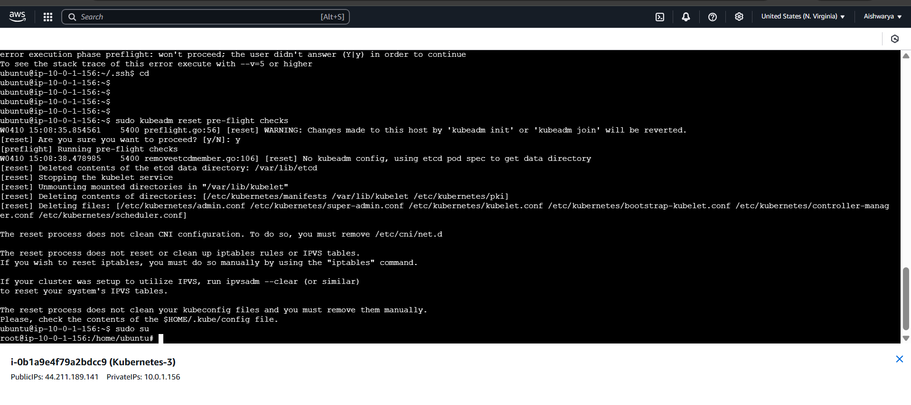

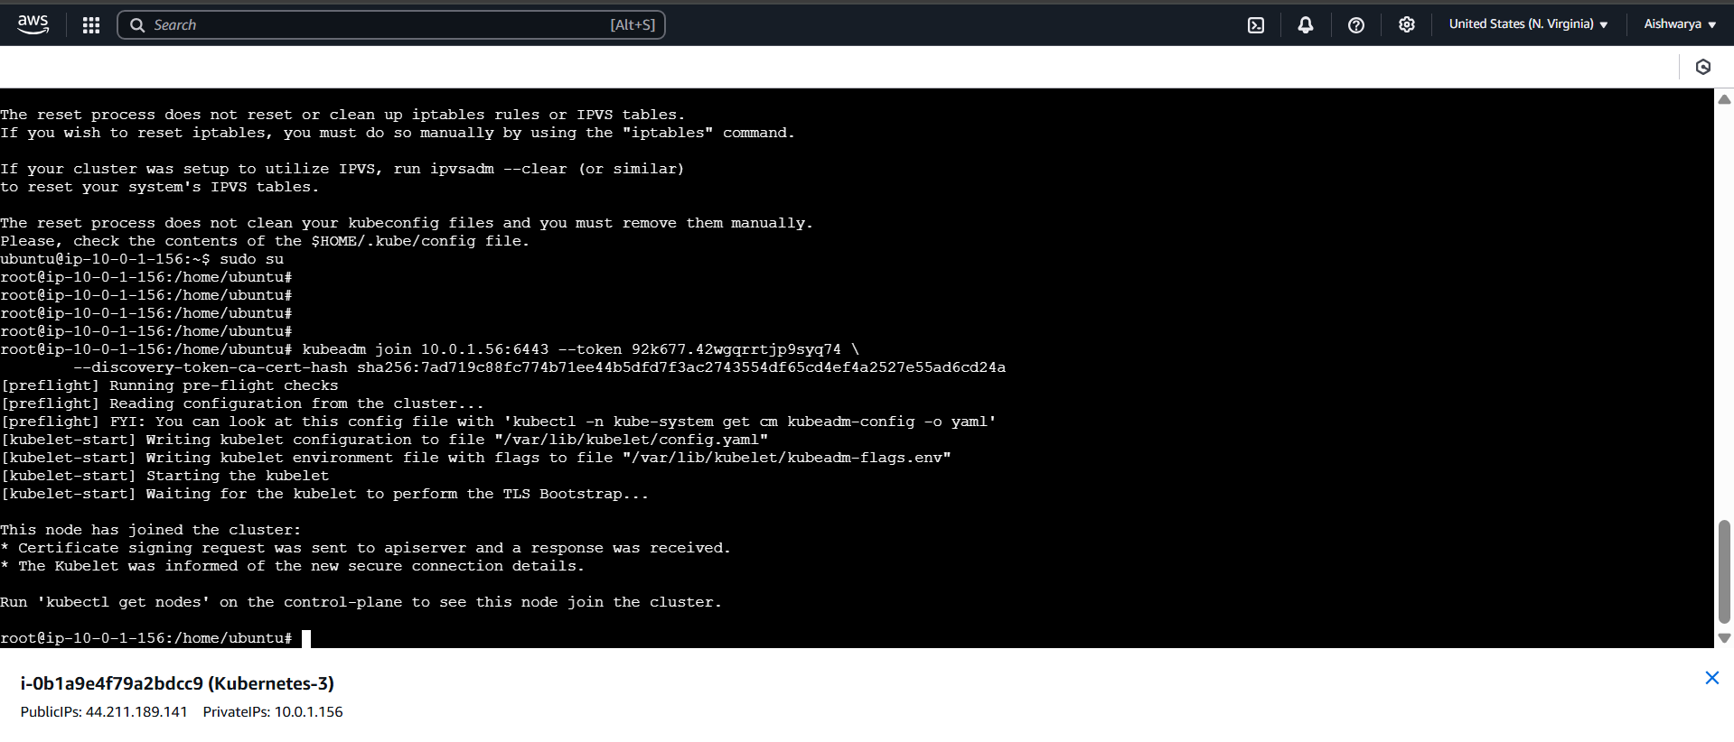

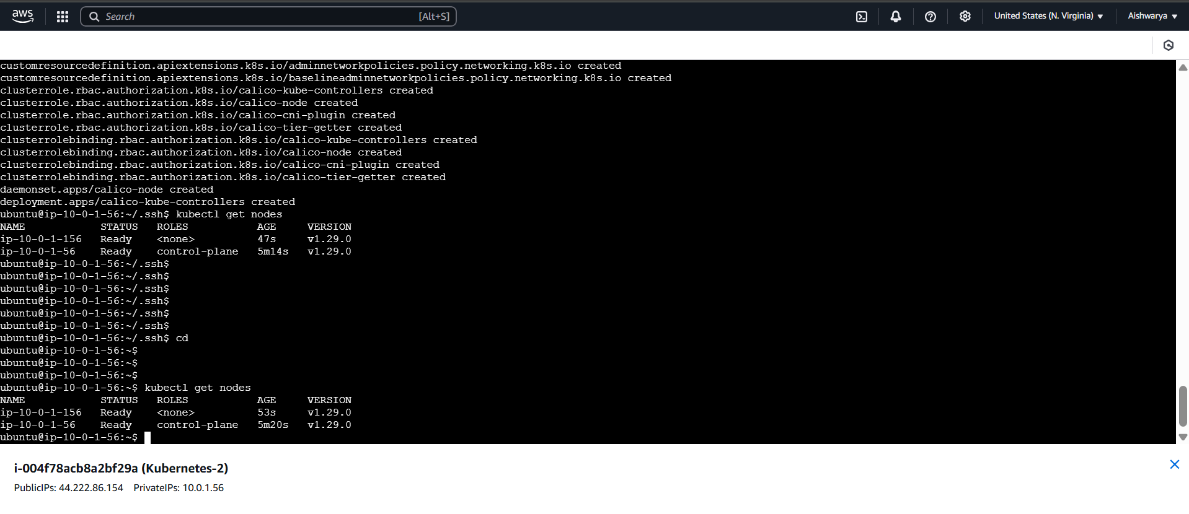

**Install docker**

**# Add Docker's official GPG key:**

**sudo apt-get update**

**sudo apt-get install ca-certificates curl**

**sudo install -m 0755 -d /etc/apt/keyrings**

**sudo curl -fsSL https://download.docker.com/linux/ubuntu/gpg -o /etc/apt/keyrings/docker.asc**

**sudo chmod a+r /etc/apt/keyrings/docker.asc**

**# Add the repository to Apt sources:**

**echo \**

**"deb [arch=$(dpkg --print-architecture) signed-by=/etc/apt/keyrings/docker.asc] https://download.docker.com/linux/ubuntu \**

**$(. /etc/os-release && echo "${UBUNTU_CODENAME:-$VERSION_CODENAME}") stable" | \**

**sudo tee /etc/apt/sources.list.d/docker.list > /dev/null**

**sudo apt-get update**

**after that**

**sudo apt-get install docker-ce docker-ce-cli containerd.io docker-buildx-plugin docker-compose-plugin**

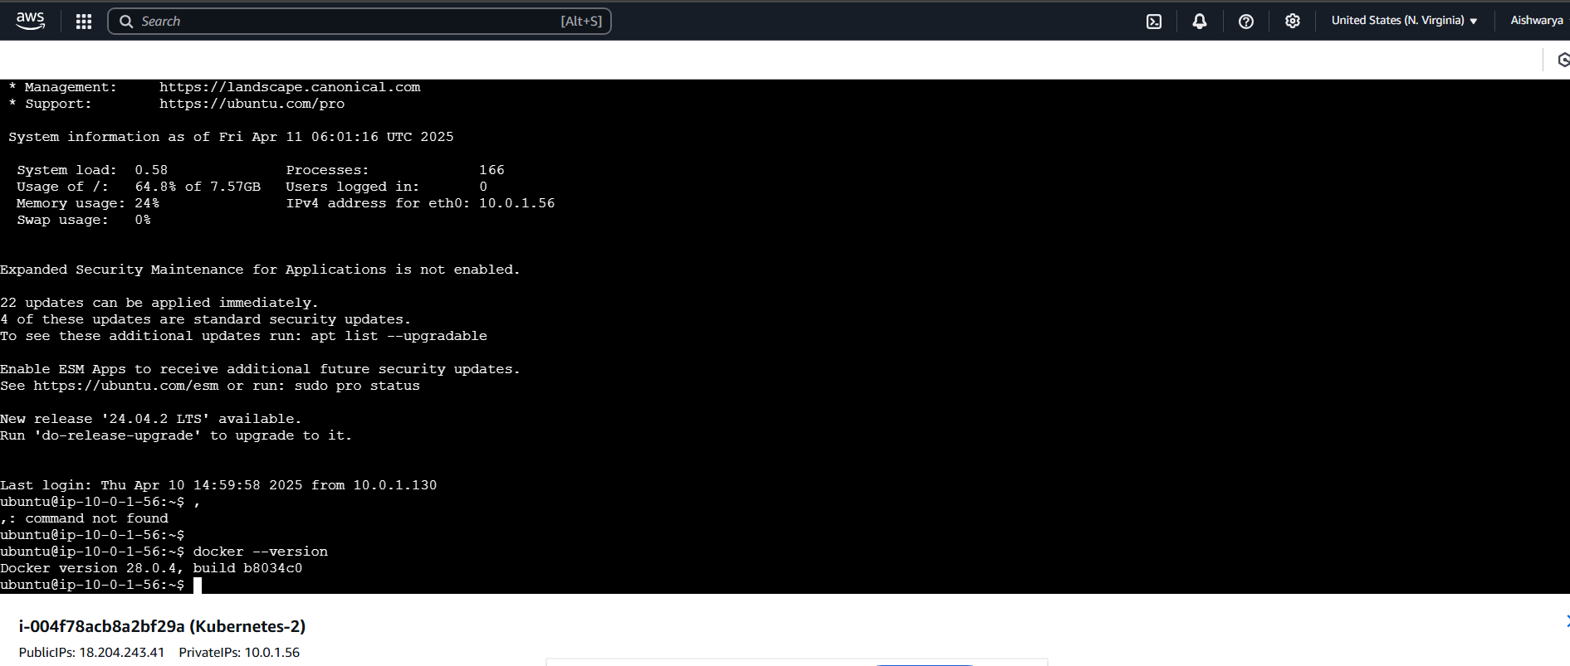

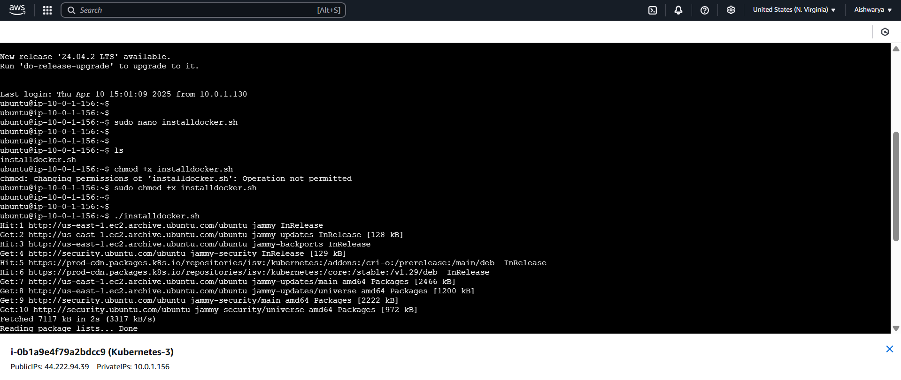

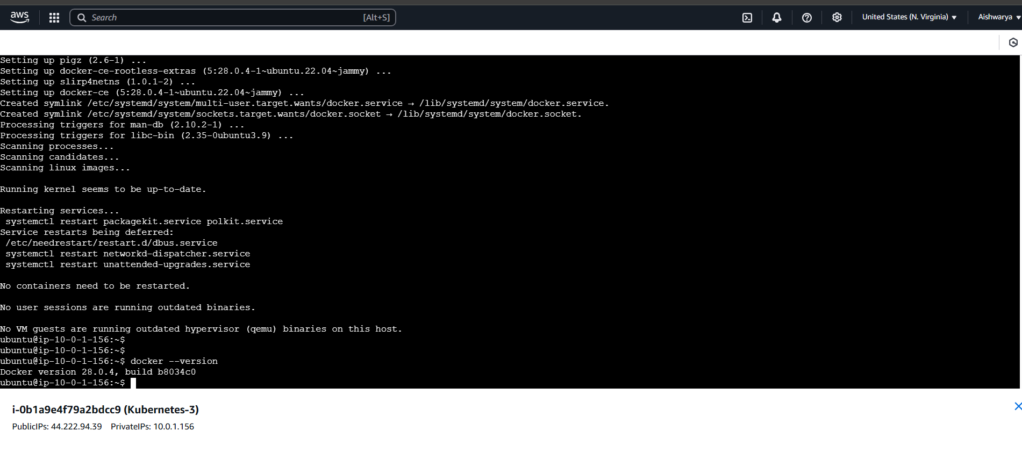

Jenkins

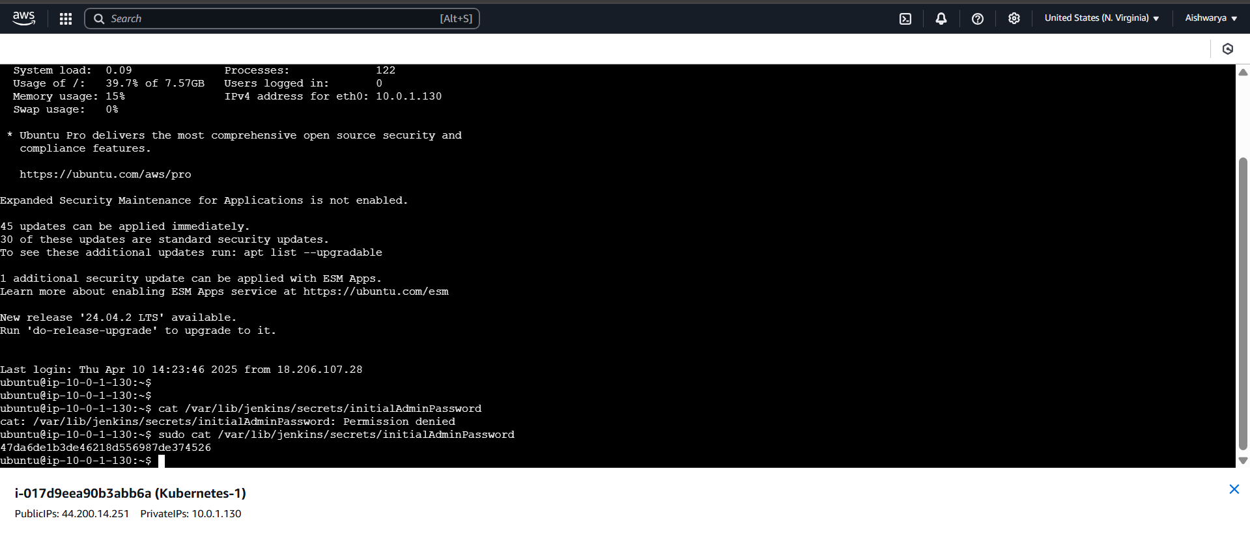

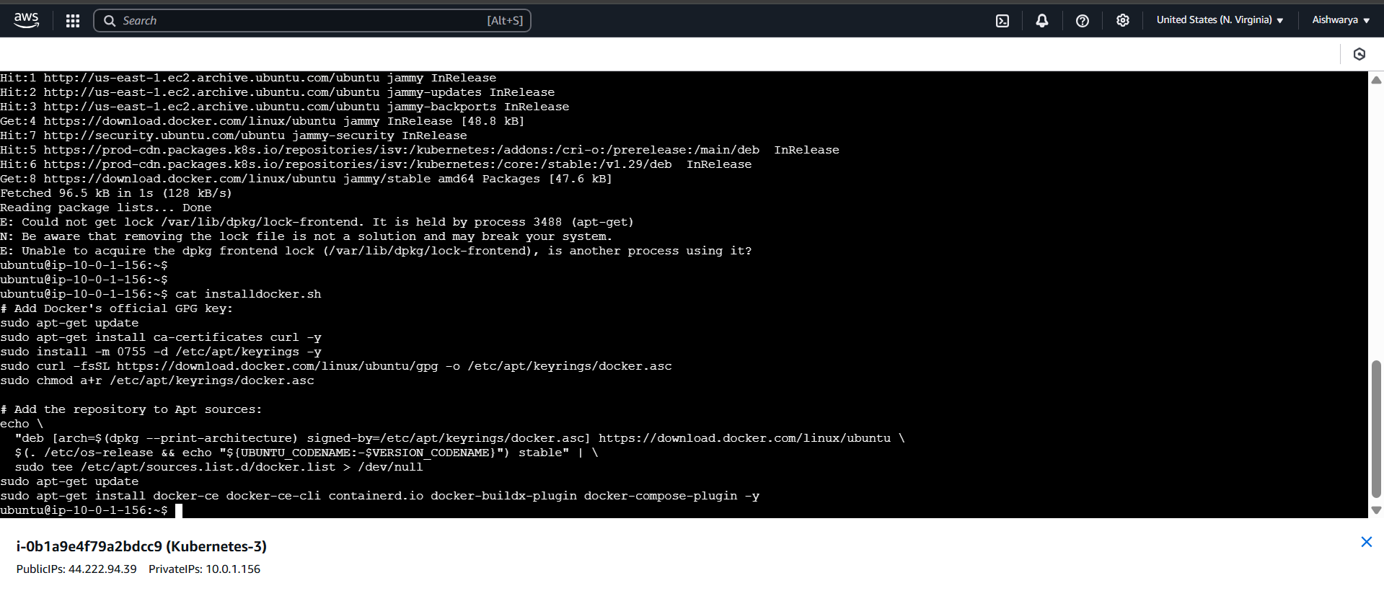

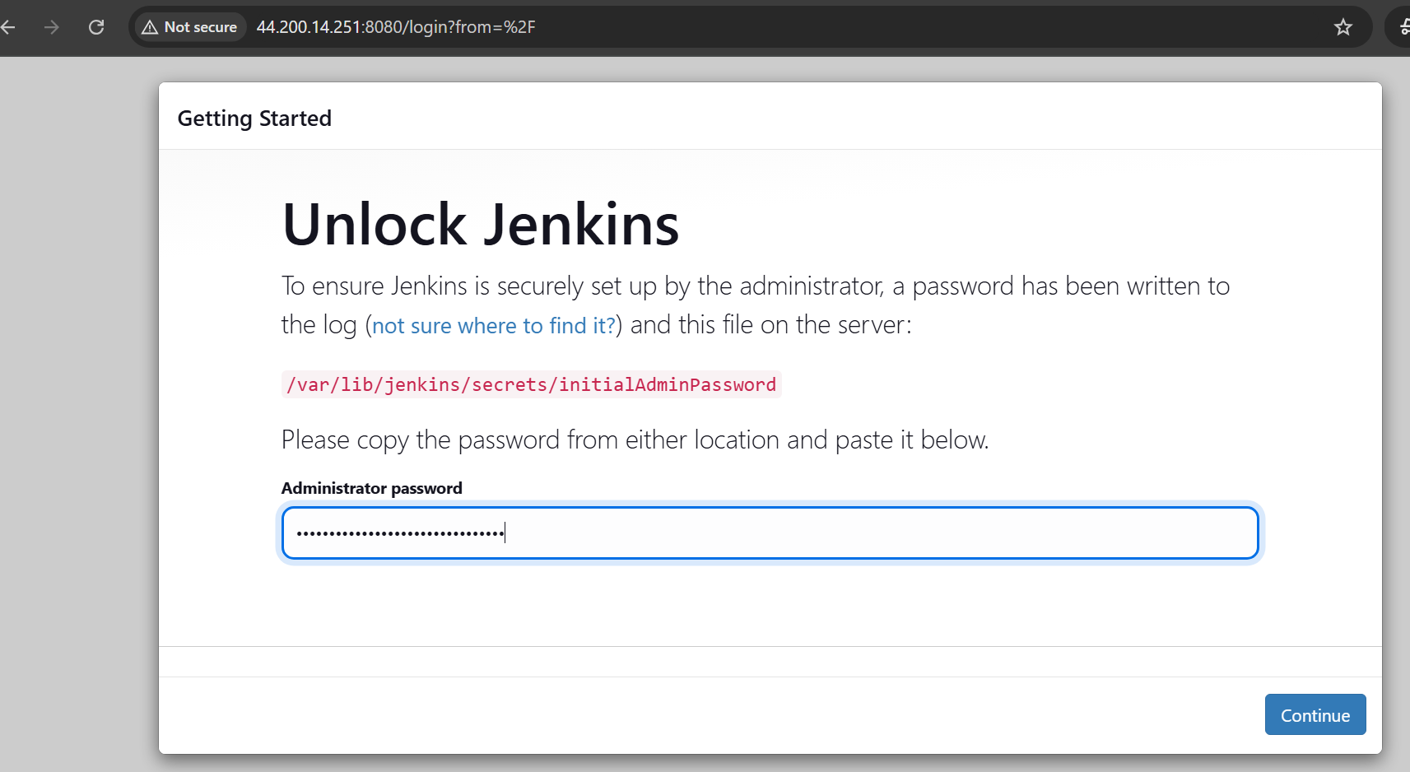

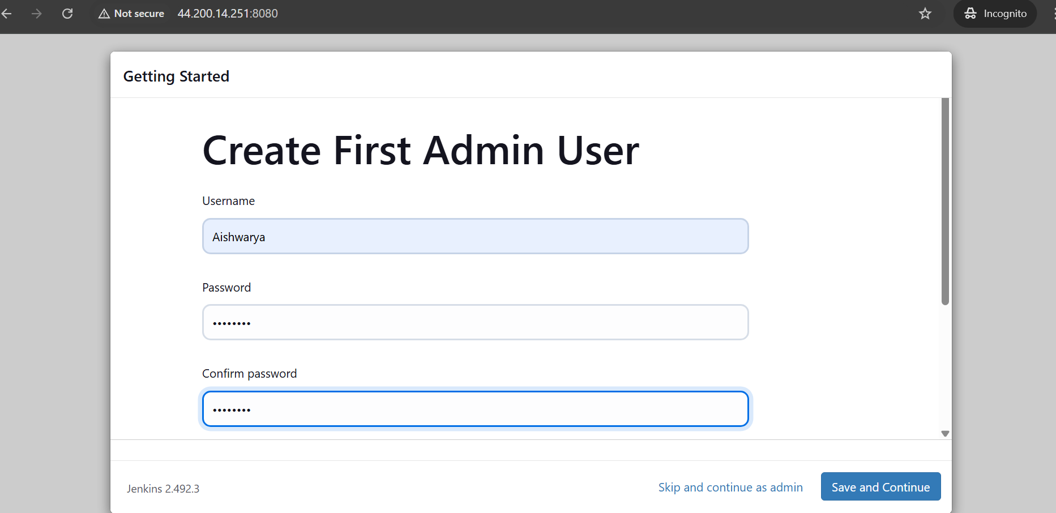

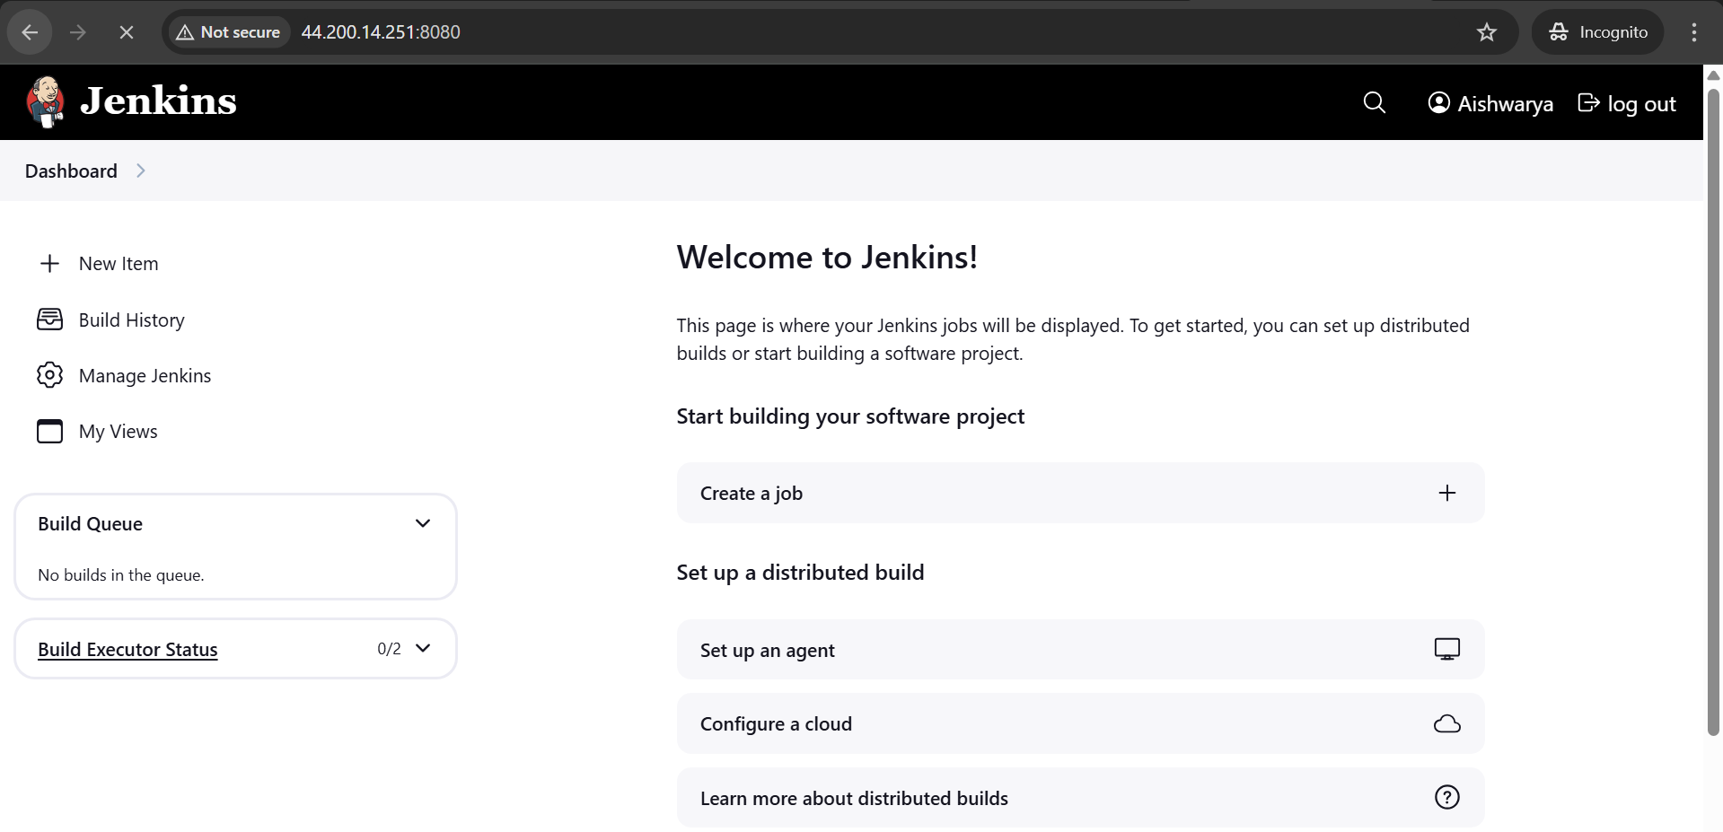

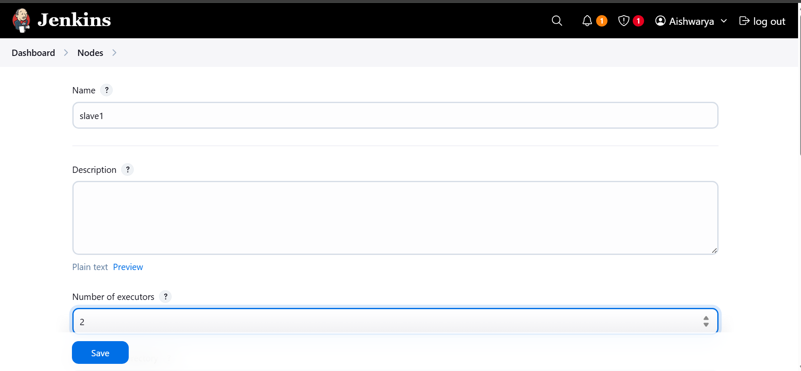

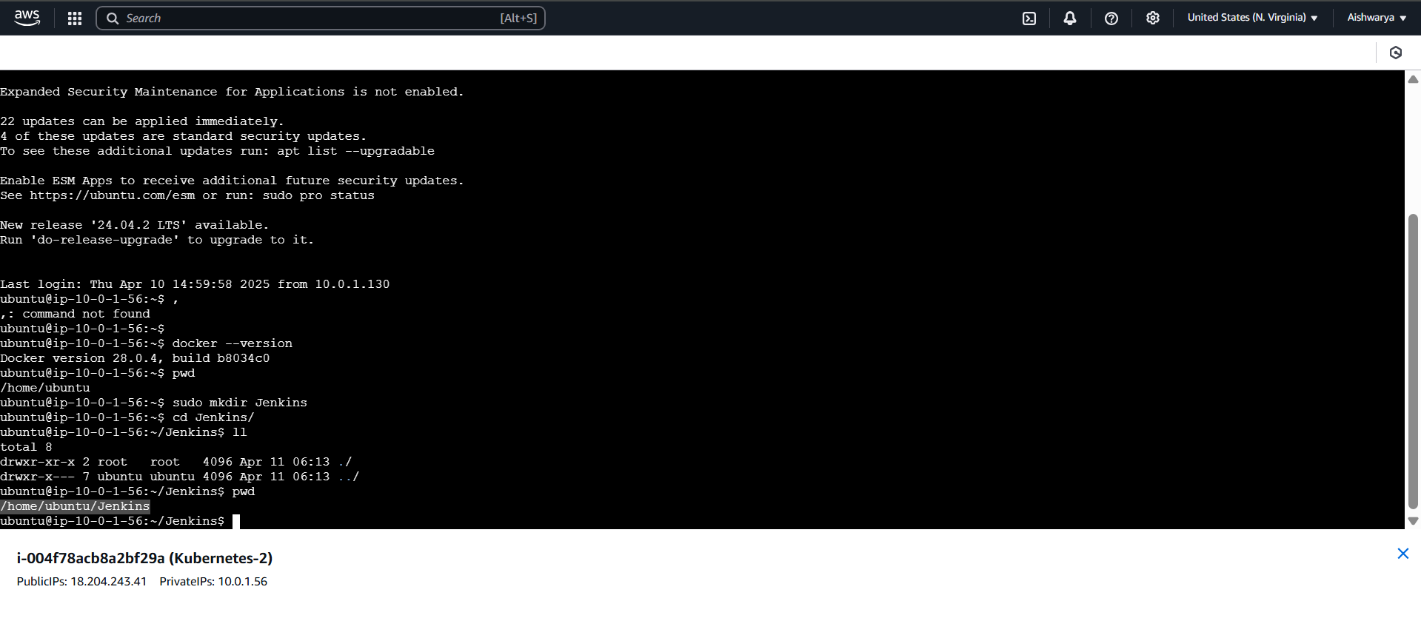

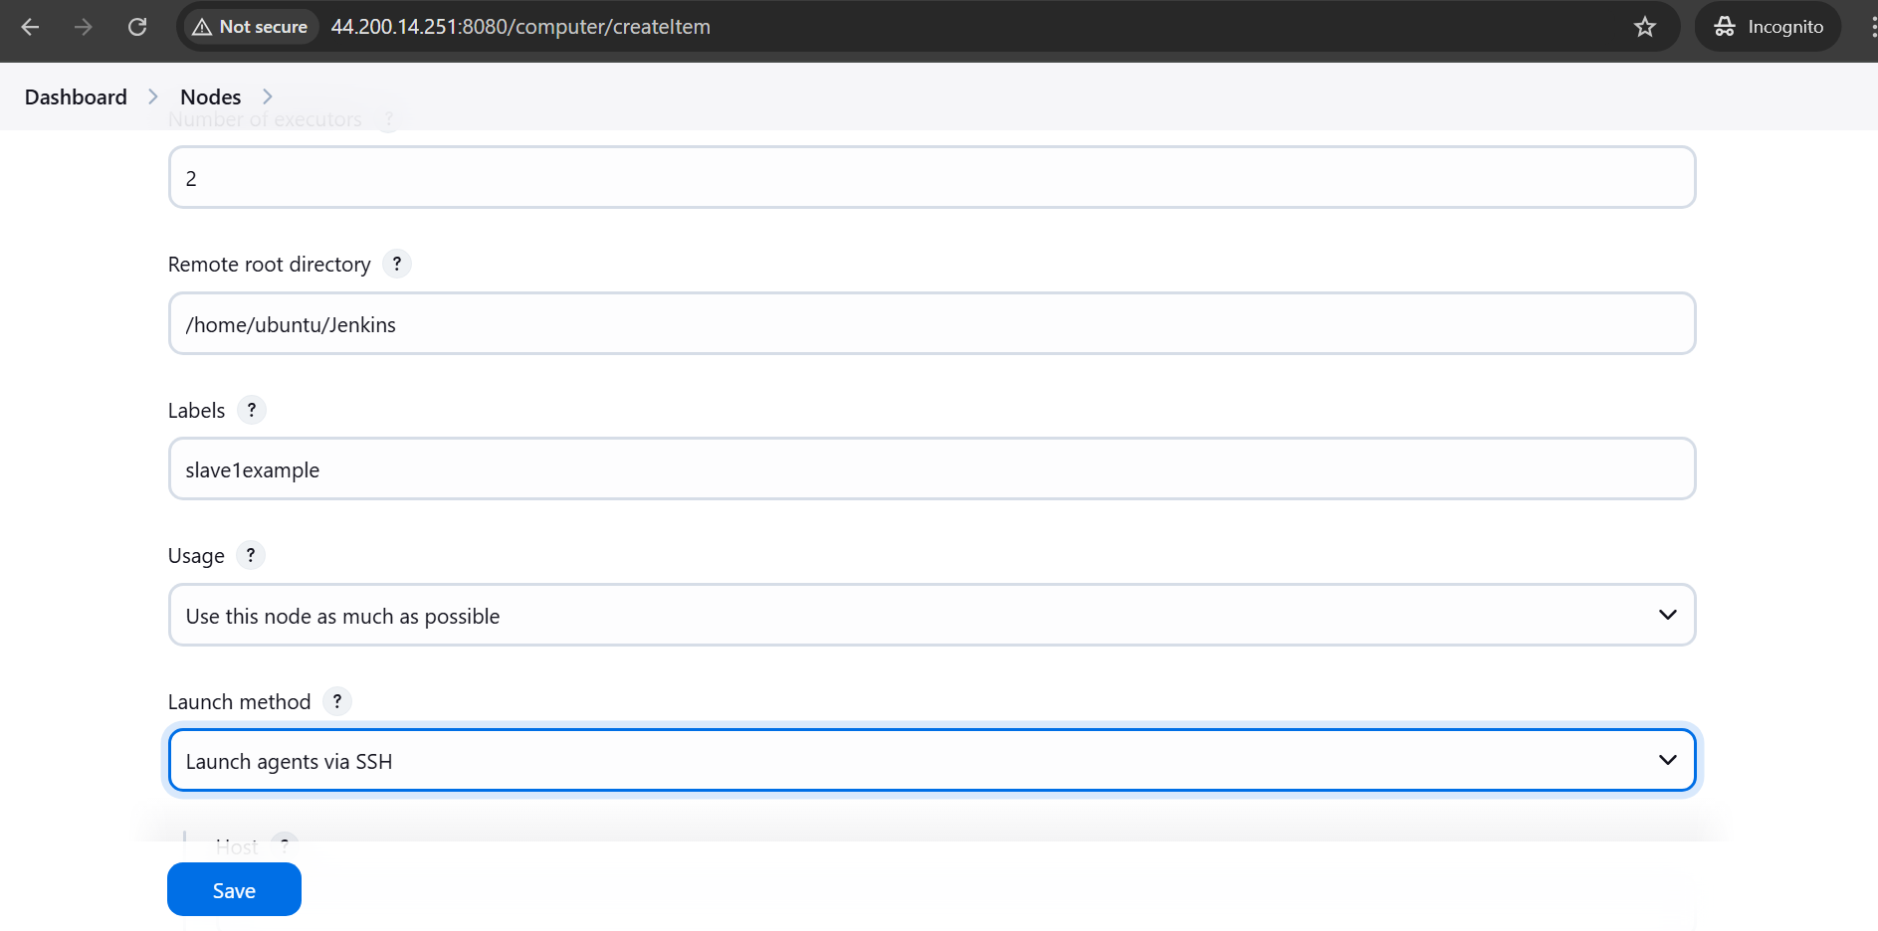

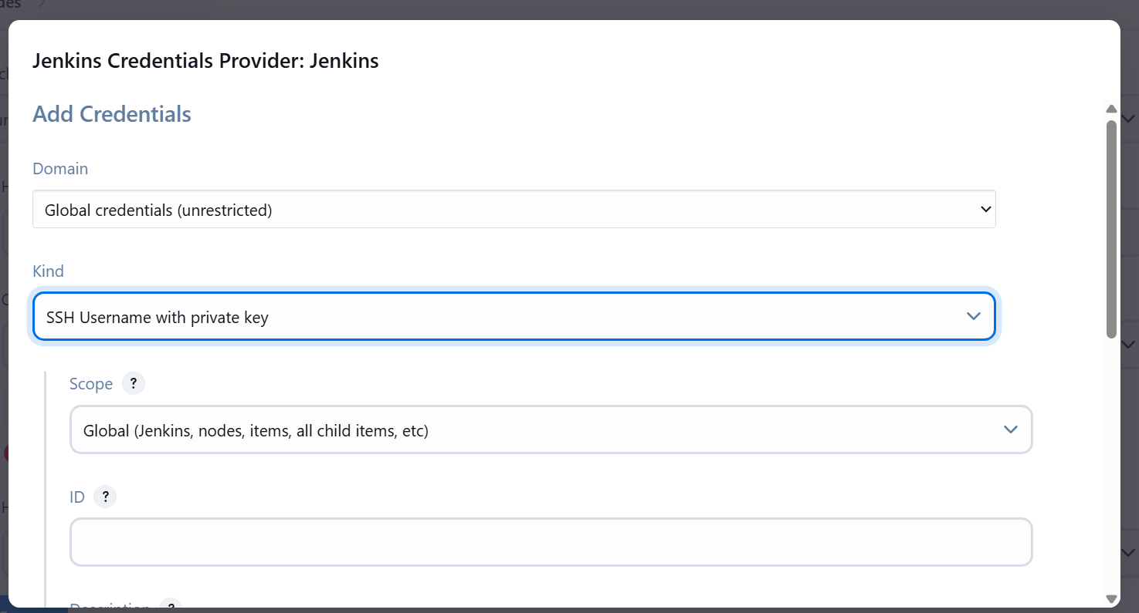

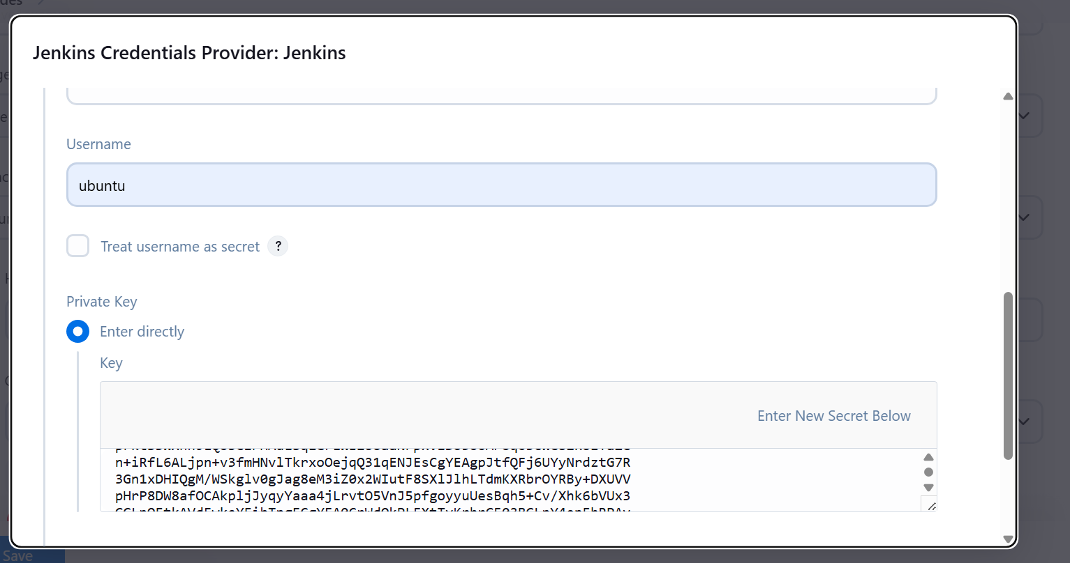



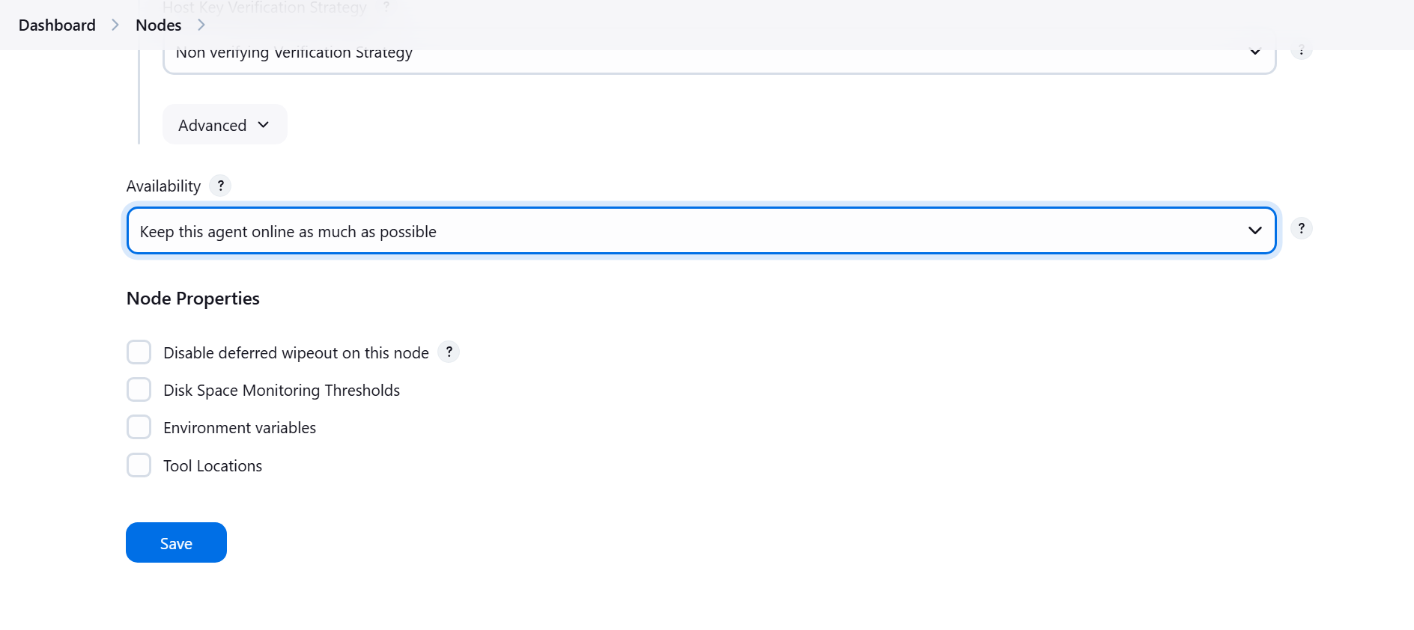

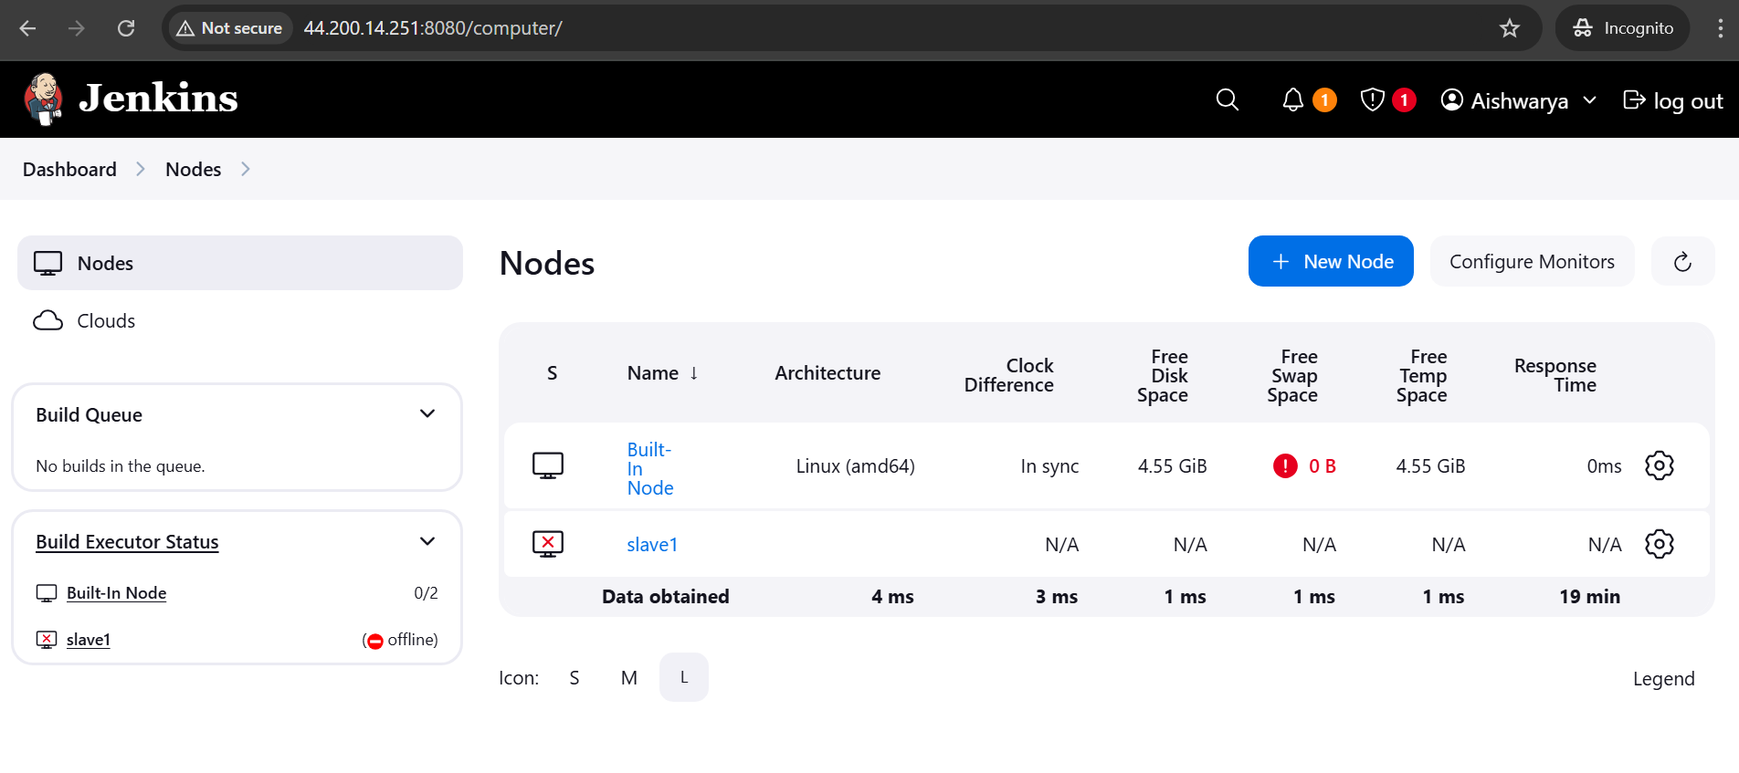

To make it online use below cmds

sudo chown -R ubuntu:ubuntu /home/ubuntu/jenkins

sudo chmod -R 755 /home/ubuntu/jenkins

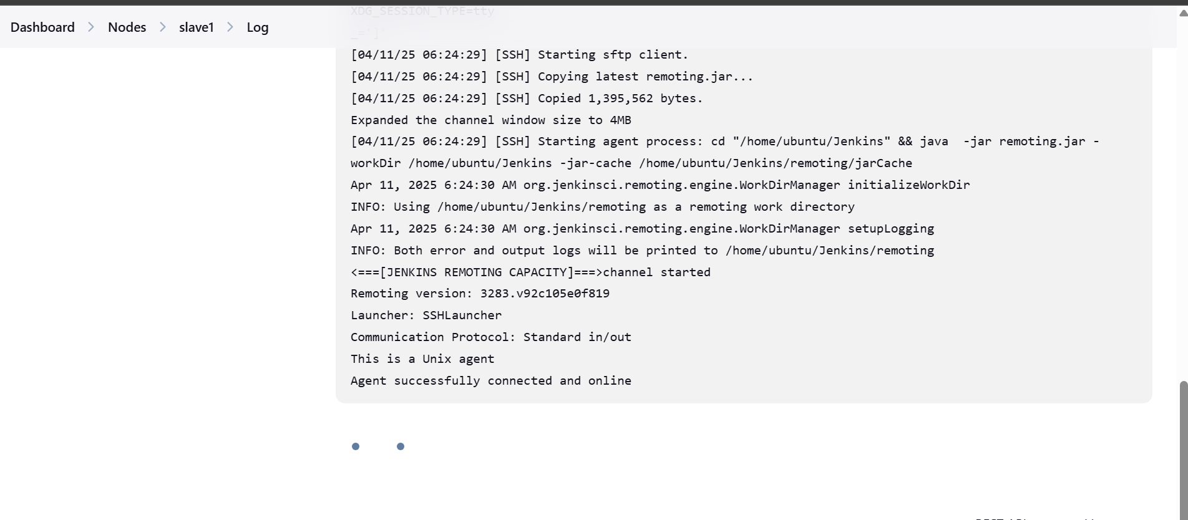

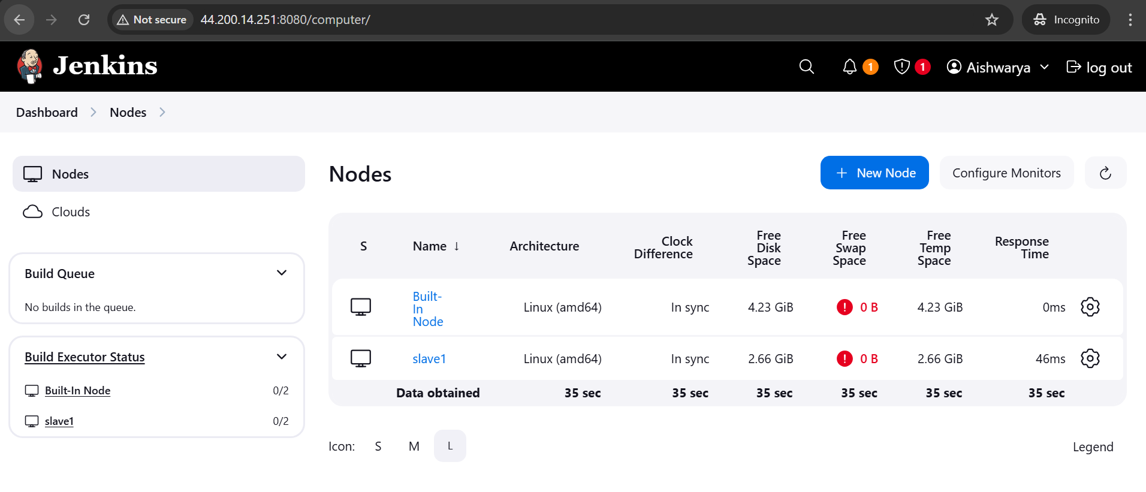

Fork the github

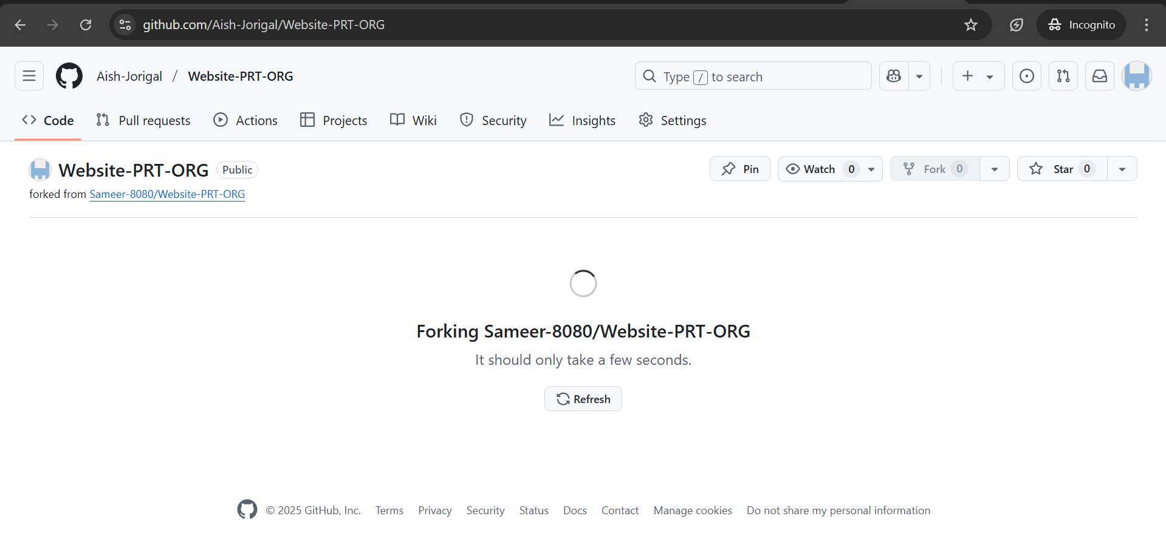

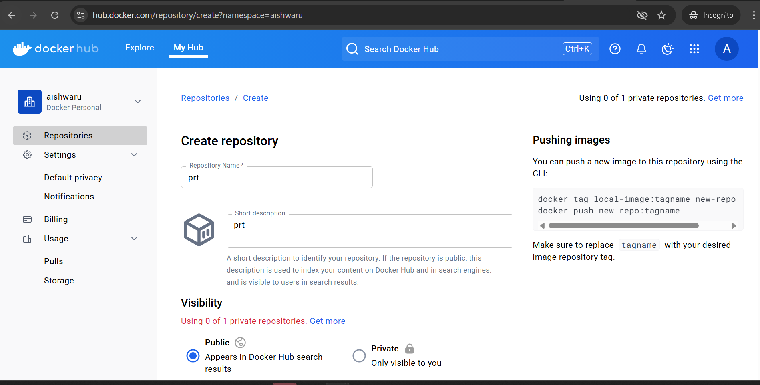

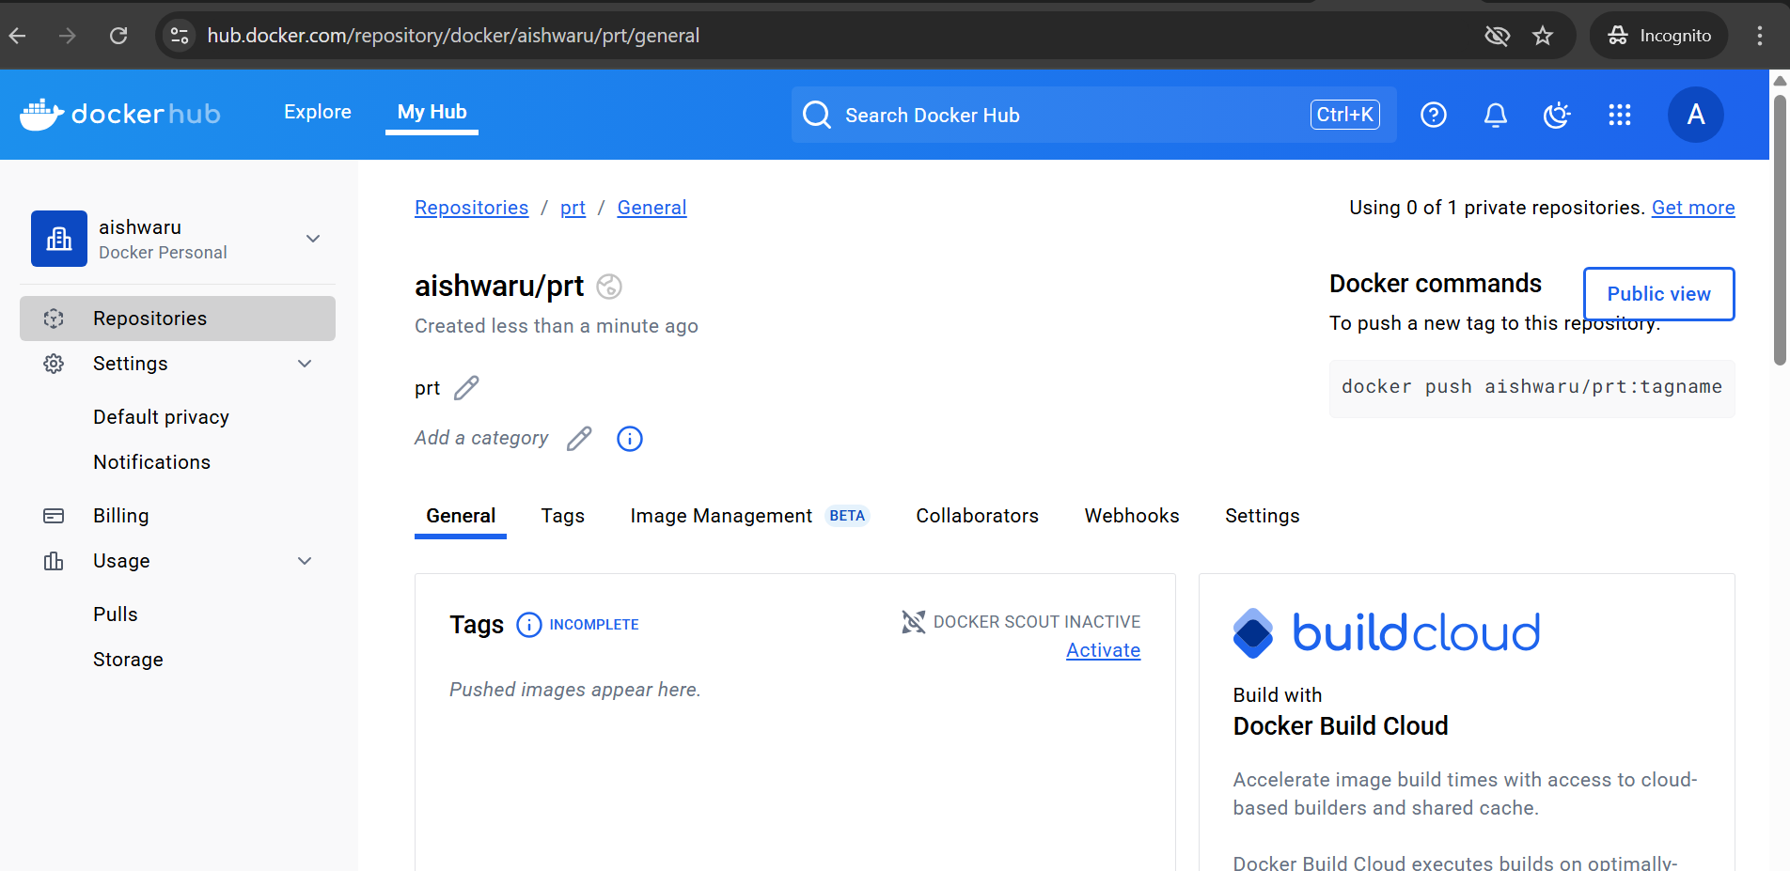

Add credential of dockerhub

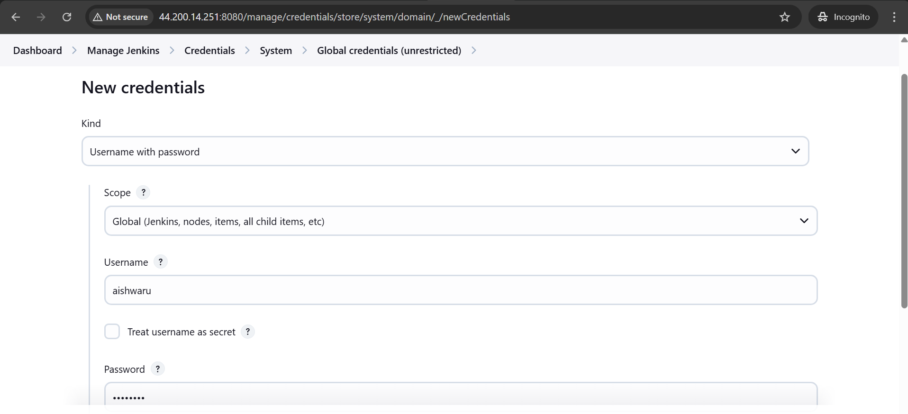

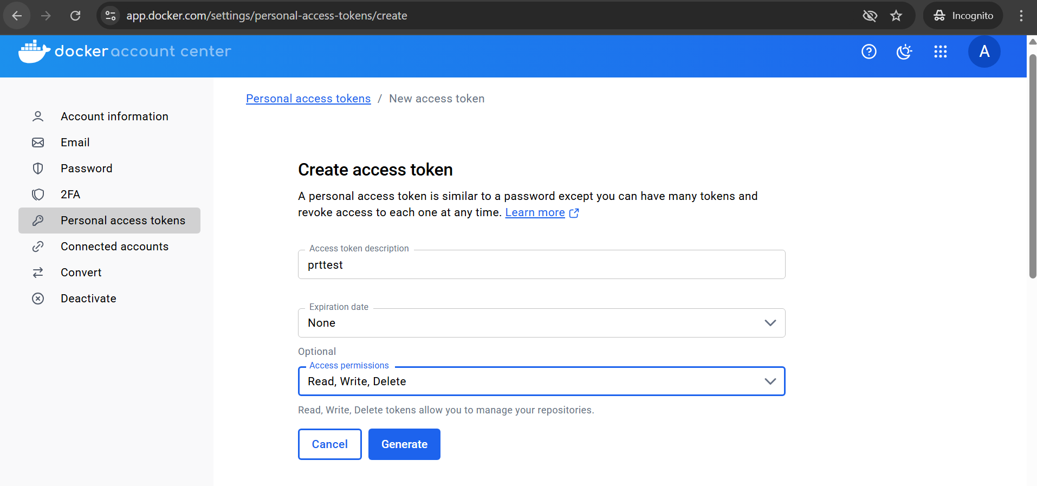

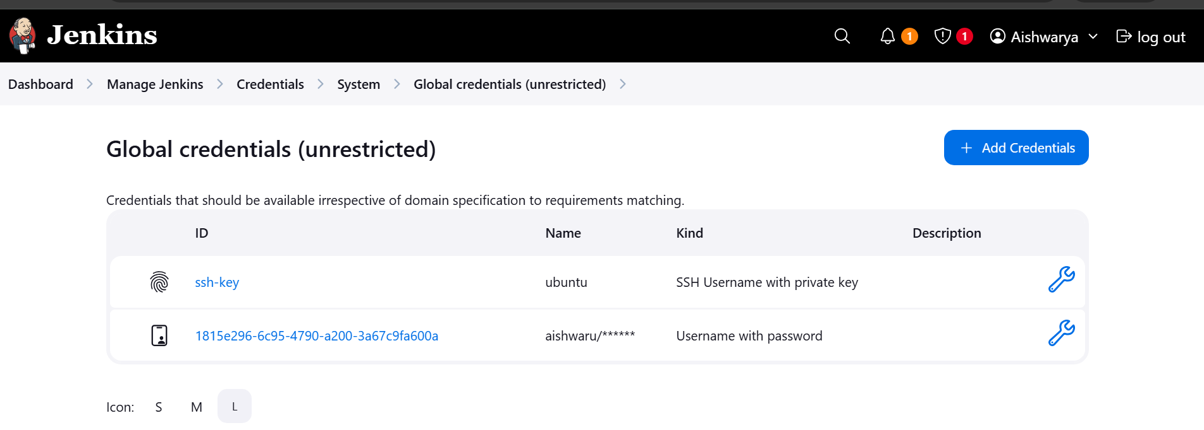

[1815e296-6c95-4790-a200-3a67c9fa600a](http://44.200.14.251:8080/manage/credentials/store/system/domain/_/credential/1815e296-6c95-4790-a200-3a67c9fa600a)

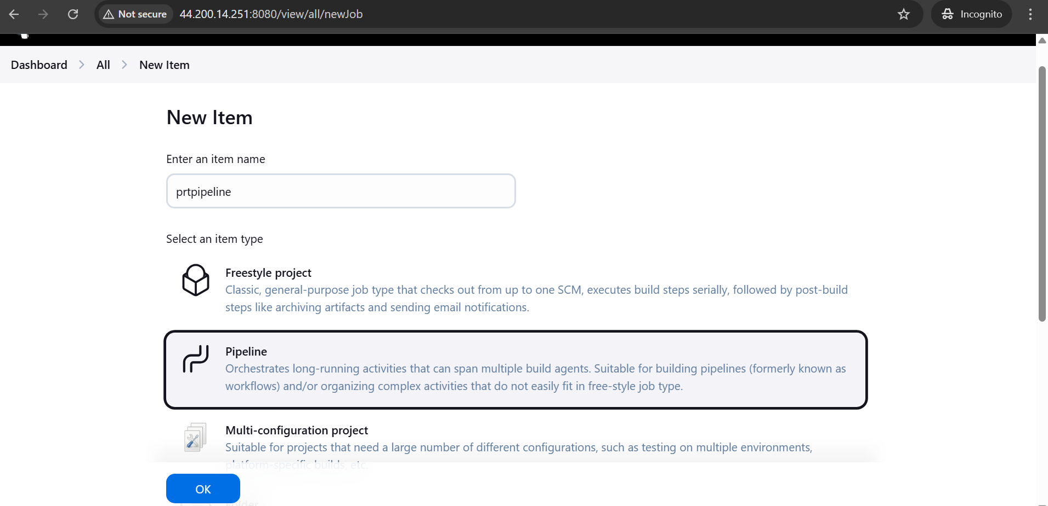

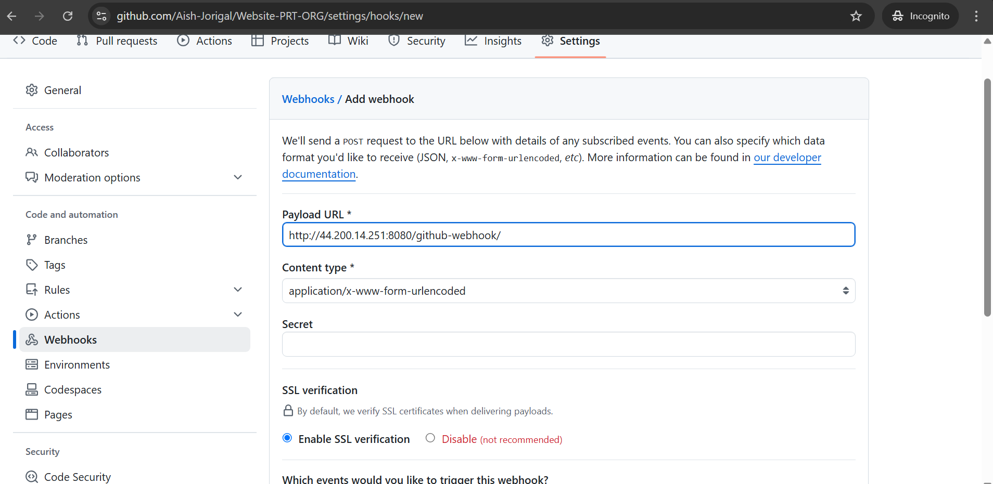

pipeline {

agent none

environment {

DOCKERHUB_CREDENTIALS = credentials("1815e296-6c95-4790-a200-3a67c9fa600a")

}

stages {

stage('git') {

agent {

label "slave1example"

}

steps {

script {

git branch: 'main', url: 'https://github.com/Aish-Jorigal/Website-PRT-ORG.git'

}

}

}

stage('docker') {

agent {

label "slave1example"

}

steps {

script {

// git 'https://github.com/Aish-Jorigal/Website-PRT-ORG.git'

sh 'sudo docker build -t aishwaru/prt . '

sh 'sudo docker login -u ${DOCKERHUB_CREDENTIALS_USR} -p ${DOCKERHUB_CREDENTIALS_PSW}'

sh 'sudo docker push aishwaru/prt'

}

}

}

stage('K8s') {

agent {

label "slave1example"

}

steps {

script {

sh 'kubectl apply -f deployment.yaml'

sh 'kubectl apply -f service.yaml'

}

}

}

}

}

FROM ubuntu

RUN apt-get update

RUN apt-get -y install apache2

ADD . /var/www/html

ENTRYPOINT apachectl -D FOREGROUND

ENV name=Devops

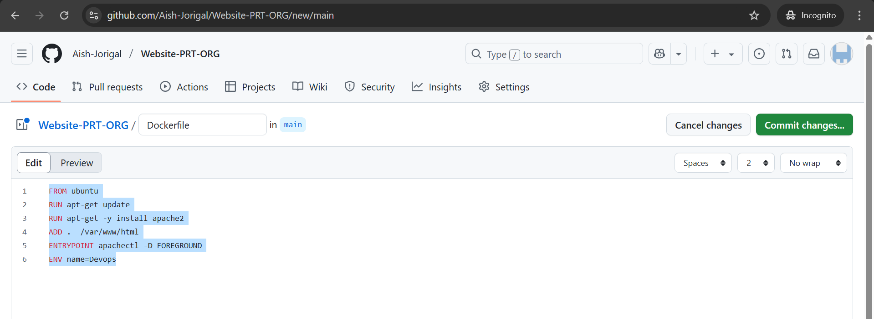

apiVersion: apps/v1

kind: Deployment

metadata:

name: nginx-deployment

spec:

replicas: 5

selector:

matchLabels:

app: nginx

template:

metadata:

labels:

app: nginx

spec:

containers:

- name: nginx-container

image: aishwaru/prt

ports:

- containerPort: 80

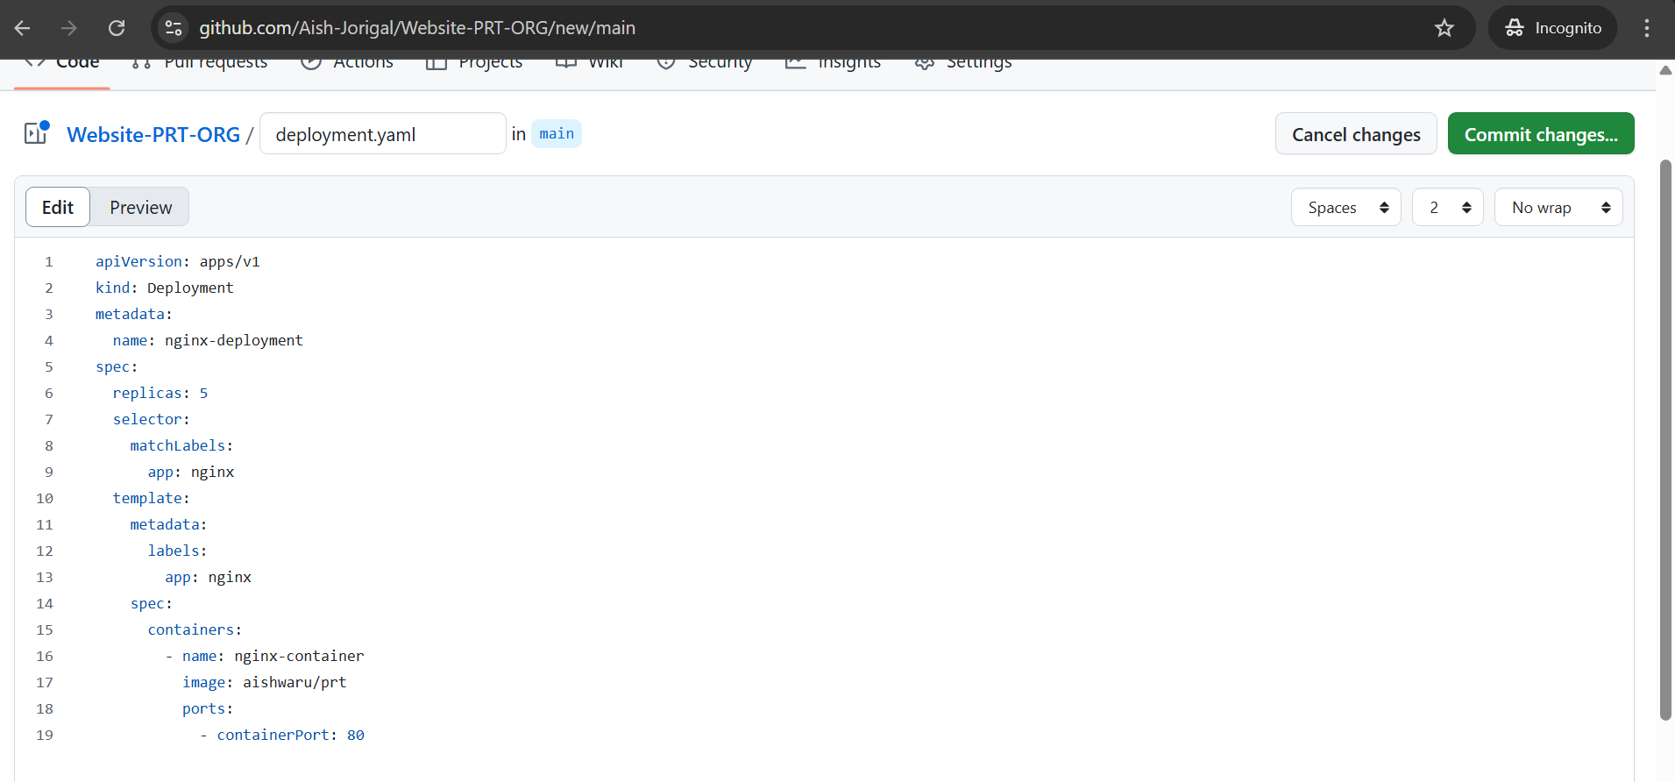

apiVersion: v1

kind: Service

metadata:

name: nginx-service

spec:

selector:

app: nginx

type: NodePort

ports:

- protocol: TCP

port: 80

targetPort: 80

nodePort: 30010

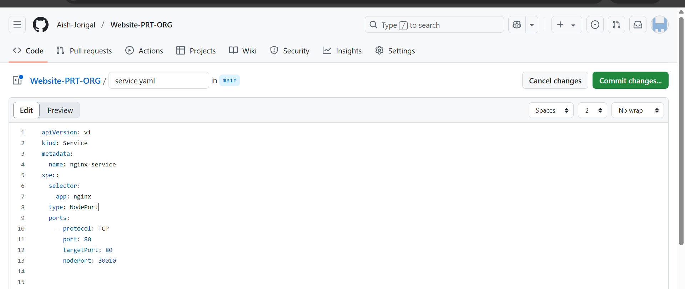

Build the pipeline

